

**VIETTEL**

**IPCC CLOUD - MYCC**

**USER GUIDE**

**PROJECT: IPCC CLOUD**

**Document:** USERGUIDE_IPCC_CLOUD_CONFIG_v1.0

**Hanoi, 07/2019**

**CONTENT**

1 USER GUIDE 3

1.1 Configure users 3

1.1.1 Add new user 4

1.1.2 Edit users 6

1.1.3 Delete user 10

1.1.4 Reset password. 10

1.2 Configure Phone number 11

1.2.1 Tab “Number Management” 12

1.2.2 Tab “Main Phone numbers” 15

1.2.3 Tab “Caller ID” 16

1.3 Configure device for users (Endpoint devices) 17

1.3.1 Configure device information on the web 17

1.3.2 Config IP Phone device 21

1.3.3 Configure with 3cx softphone 26

1.4 Configure Callflows (Voice Inbound) 29

1.4.1 Media 30

1.4.2 Configure Menu 32

1.4.3 Queues 34

1.4.4 Configure Time of Day 38

1.4.5 Configure Callflow 40

1.5 Configure Email Account 45

1.6 Configure Domains (chat) 49

1.6.1 Add new domain 50

1.6.2 Edit Domain 51

1.7 Assign Agent to Queue Chat / Queue Ticket 58

1.7.1 Assign agents to Queue 58

1.7.2 Remove agents from Queue 60

1.8 Business Hours 60

1.8.1 Working hours 60

1.8.2 Holidays 64

1.9 Manage Facebook page 67

# USER GUIDE

## Configure users

* Manage users
* From menu : choose Settings/ Users:

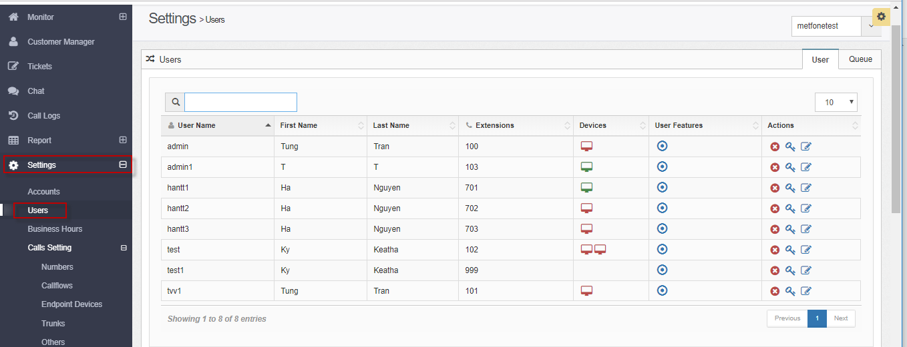

* + First: choose department :

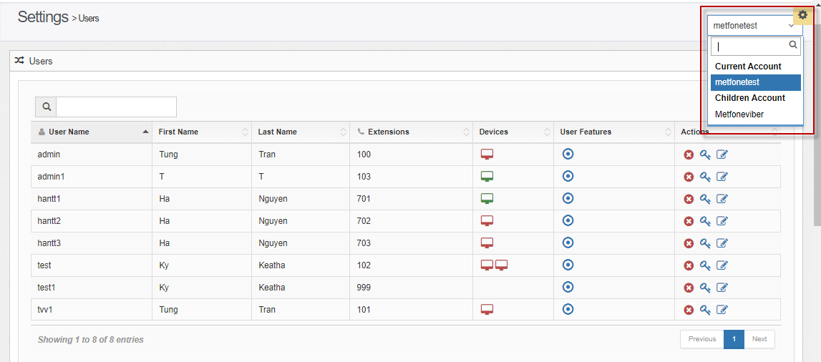

The screen displays the user list of the department:

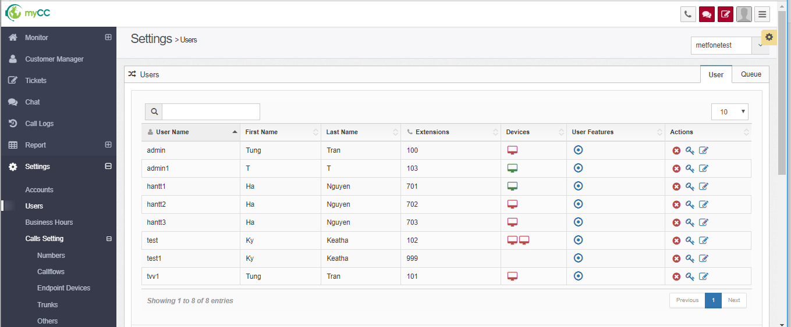

### Add new user

* Step 1: Choose department.
* Step 2: Click button Add 🡪 it shows a popup:

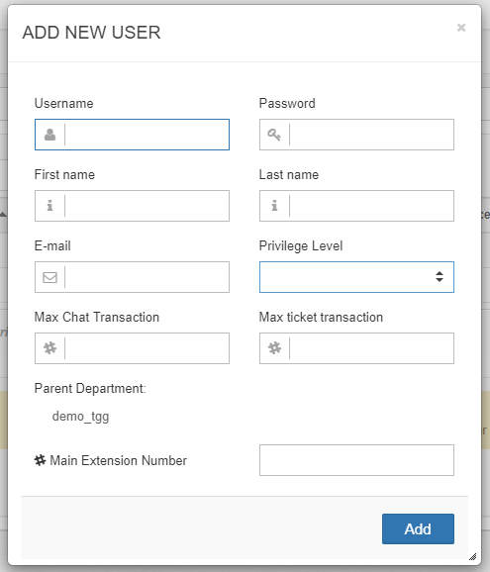

* Step 3: Input information:

Username: Username is not the same as others

Password: at least 6 characters

Firstname:

Lastname:

Email: Enter the correct email format

Privilege Level: choose one value:

Admin: Users have all the menus on the site, including settings

Supervisor : Users have multiple menus on the site, not including settings

User: Users has no right with Monitor and Settings.

Max Chat transaction: only allow numbers, from 0 to 999 (maximum number of chat the agent can receive at a time)

Max ticket transaction: only allow numbers, from 0 to 999 (maximum number of tickets the agent can receive at a time)

Main extension number: only allow numbers, from 100 to 999 (in the system, agents can call others via extension)

Parent department : You can choose, if not selected, the default of the parent department is the Enterprise of admin logging in

* Step 4: Press button “Add”.
  + If the data is valid ➔ The record will be displayed on the List
  + If the data is invalid ➔ The record is not added to the system.

### Edit users

* From list users, click icon “Edit” of user need to change.

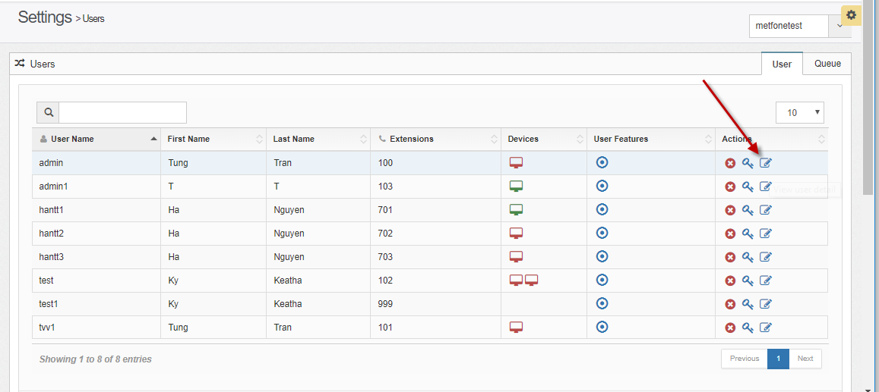

* It shows:

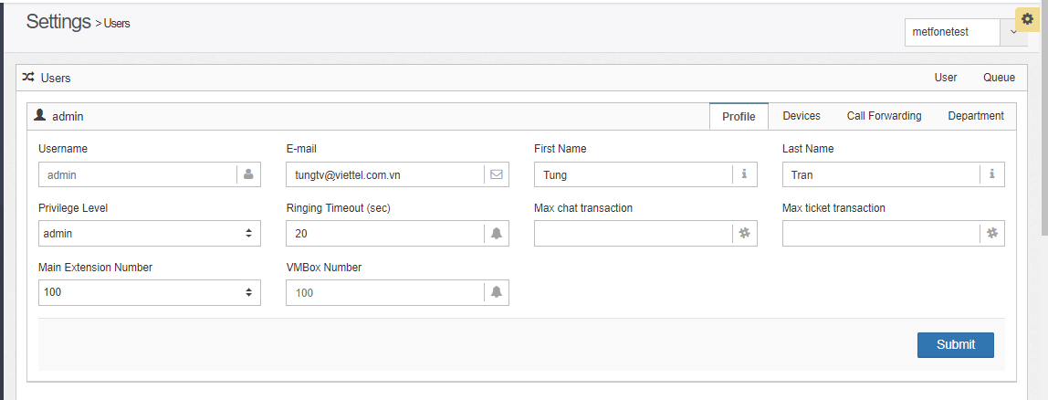

#### Tab “Profile”

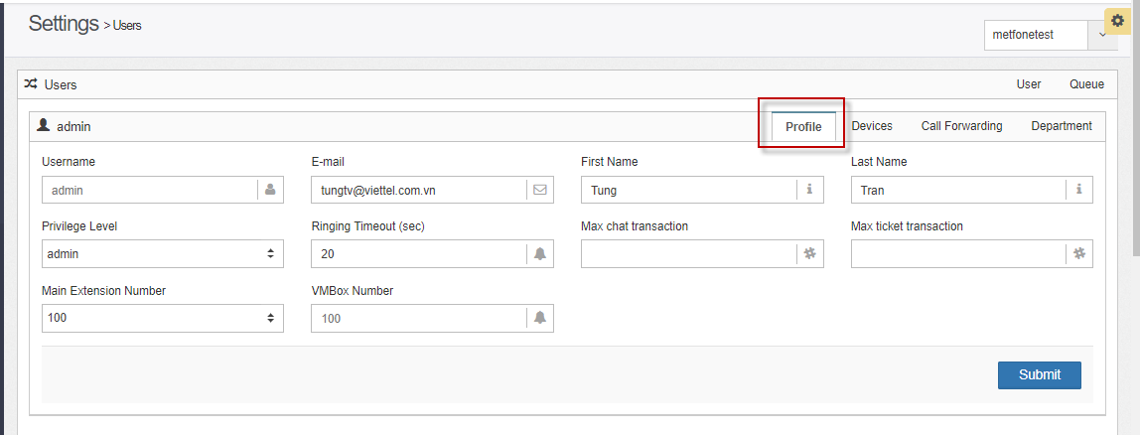

* Information on the screen:

o Username: must not be changed

o Ringing timeout (secs): default: 20s, change allowed.

Admin Example admin agent1 has time ring (seconds): 20s, on the system has direct callflow to admin1 without Queue => Call to agent within 20s, agent does not pick up, call will be disconnected.

Main extension number : not allow to change.

o Voicemail number (vmbox): not changed, this value is generated by the system when creating users

o Other information (Email, Name, Last Name, Authorized Level, Max chat transaction, Max ticket transaction): allow to change

* - User changes information, press "Submit" button to save.

#### Tab “Device”

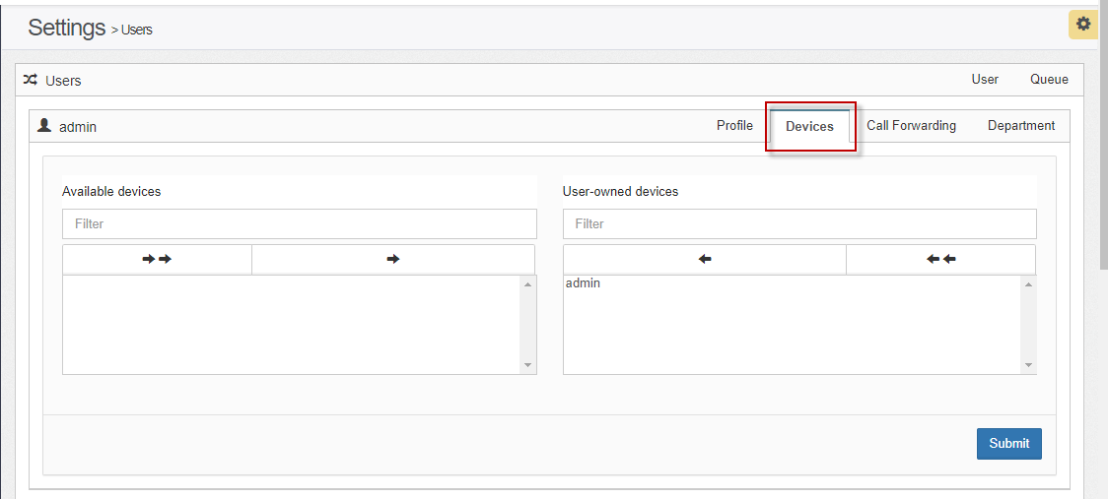

* Assign devices to user:
  + Choose device from left frame 🡪 click icon to assign
  + Click “Sumit” to save.
* Remove device from user:
  + Choose device from righrt frame 🡪 click icon to remove
  + Click “Sumit” to save.

#### Tab “Call Forwarding”

* Default: Call Forward function has state **“OFF”.**

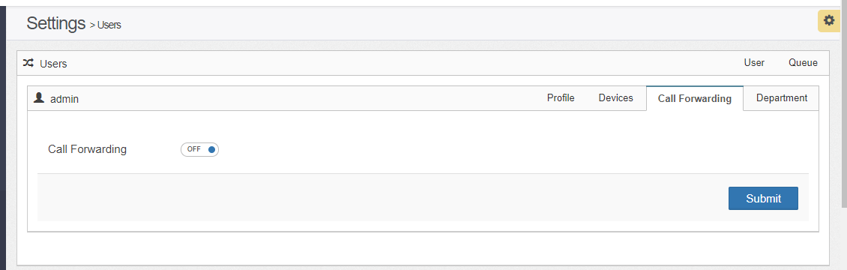

* When you click button  🡺 it shows:

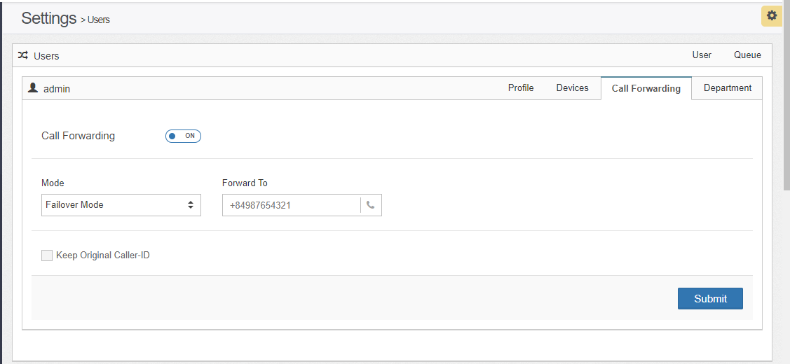

* Input information:
  + Mode: choose one from 2 options:
    - Failover Mode: connect to agent's device failed -> execute forward
    - Always Mode: always forward call to phone number
  + Forward to: input phone number
  + Checkbox Keep Original Caller – ID :
    - If checkbox is checked 🡺 When transferring to the agent, display the customer phone number
    - If checkbox is unchecked 🡺 When transferring to the agent, display the hotline of contact center.

#### Tab “Department”

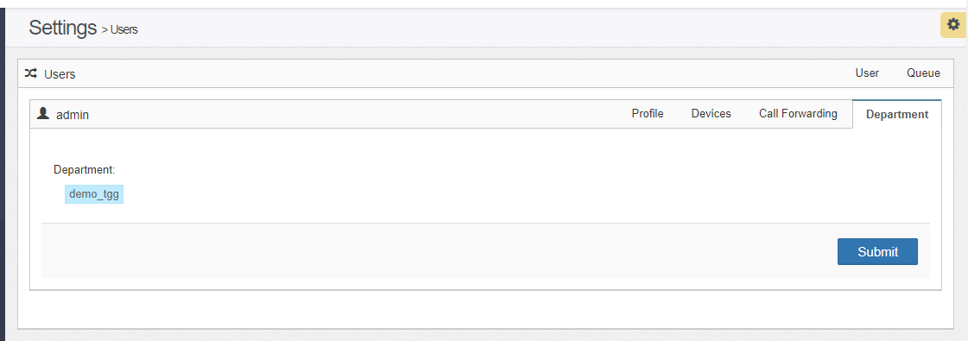

- Allow to re-select the parent department of the user:

* + Reselect the department in the department tree
  + Click the "Submit" button to save

### Delete user

* Step 1: From list users, click icon Delete at which row you want to delete:

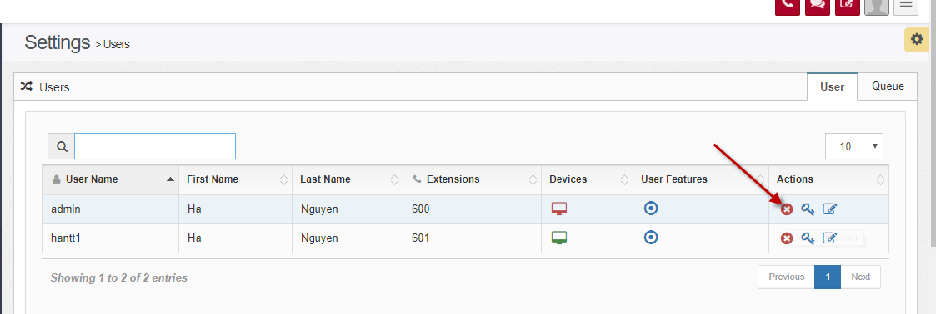

* It shows a confirm:

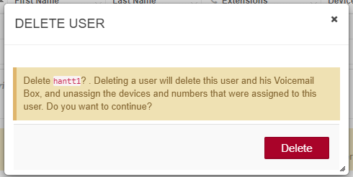

* Step 2: Click Delete button to delete.

### Reset password.

* From list users, click icon “Set user’s password” :

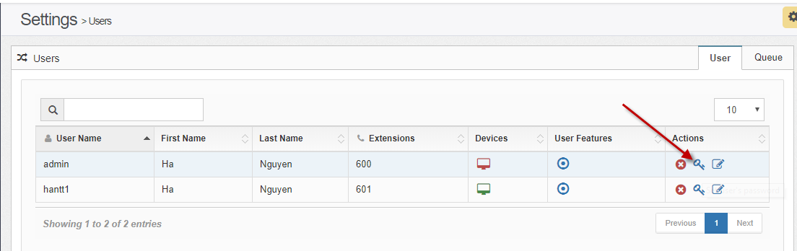

* It shows:

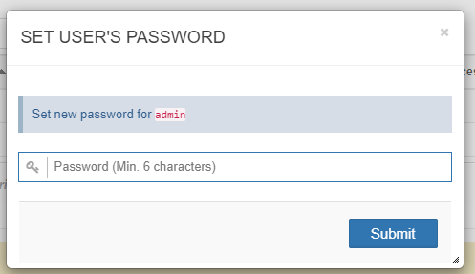

* Step 2: input new password
* Step 3: Click Submit button

## Configure Phone number

* - The function to create phone numbers for businesses, this number is the number provided to customers calling on the switchboard of the business.
* - Users with Superadmin rights are allowed to add phone numbers for businesses, assign key phone numbers to businesses. Users with admin rights of businesses are not allowed to add phone numbers for businesses, only allowed to assign the main phone numbers for businesses.
* You choose from the menu : Settings/Calls setting/ Numbers.
* If you login with superadmin power 🡪
* Go to Settings menu/ Phone number:
  + The screen displays the list of phone numbers according to the enterprise selected in the combobox on the right, just below the Status icons.

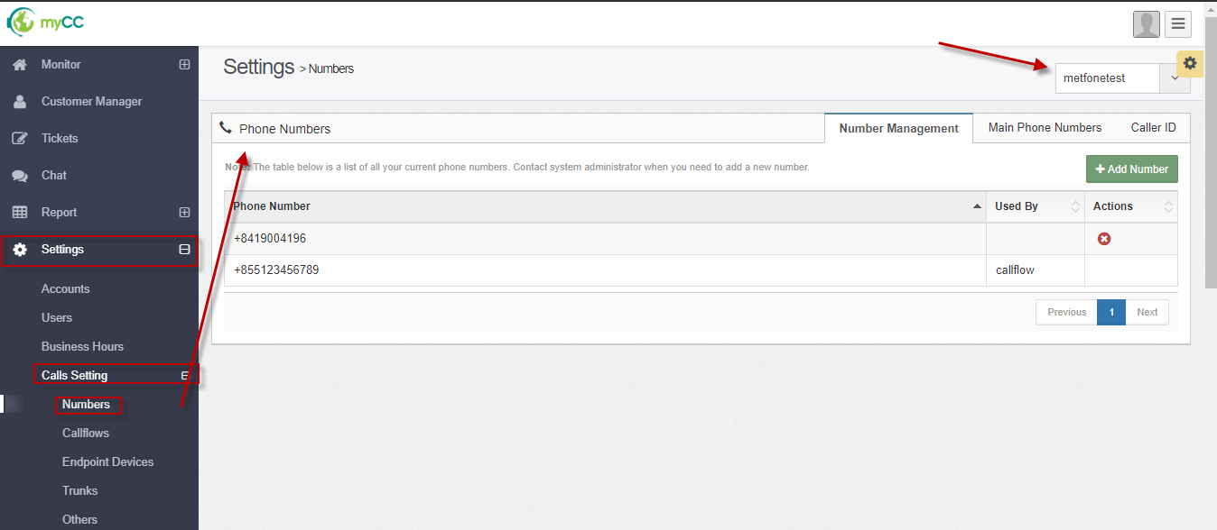

* + If you login as business’s admin 🡺 The screen only displays the phone number list of the respective business.

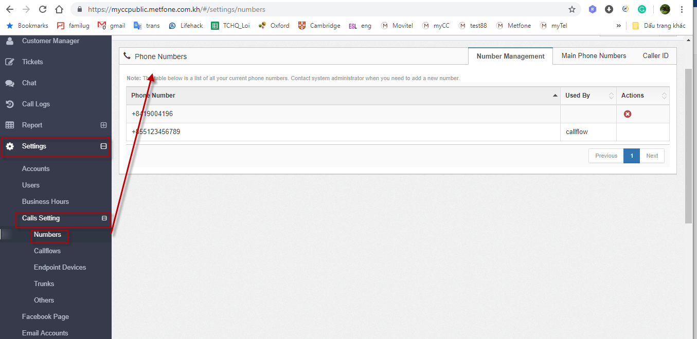

### Tab “Number Management”

* The function allows users to add / delete phone numbers of businesses – input for configuring callflows.
  + Phone number can be assigned to the main phone number of the enterprise 🡪 When the customer calls this phone number, the system will process according to the call MainOpenHour.

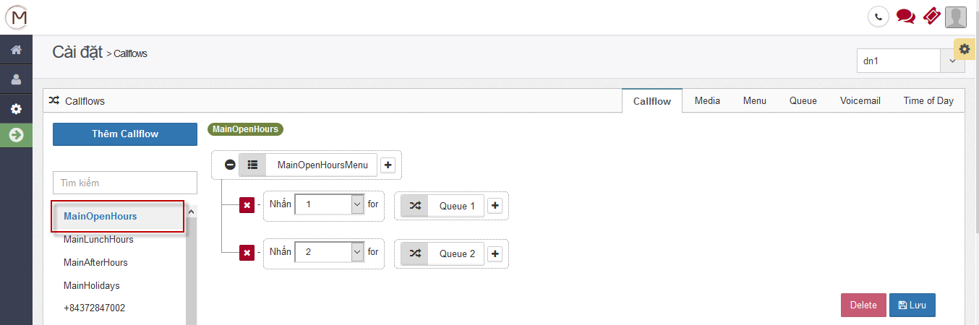

* + If the phone number is not assigned to the main phone number of the business, it is necessary to configure the callflow for it at menu Calls setting/Callflows. When the customer calls this phone number, the system processes according to the own callflow, do not handle the callflow Main Open Hour.

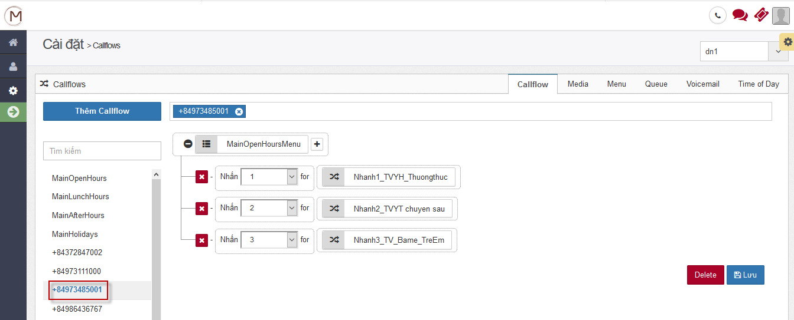

#### Number management – login with Superadmin account.

##### Add new phone number

* Step 1: On Numbers setting screen, choose *Number Management* tab:

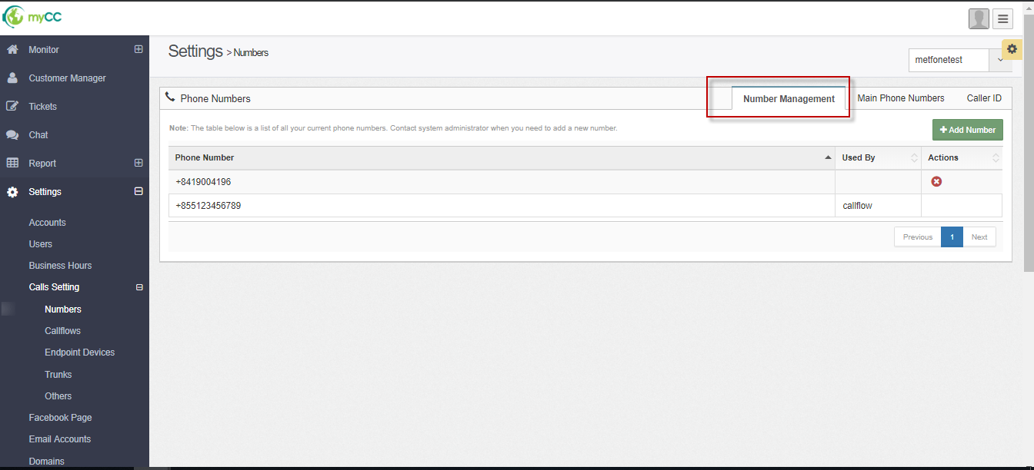

* Step 2: Click button **“Add number”:** it shows:

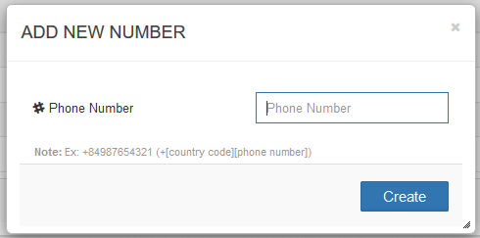

* Step 3: Enter phone number of your company.
* Step 4: Click button **“Create”**.
  + If the data is valid, the phone number will be displayed on the List
  + If the data is invalid , the phone number is not added to the system.

##### Delete phone number

* Phone number only shows Delete icon when satisfied simultaneously

o It has not been assigned to the main business phone number list

o It has not been assigned to any business callflow

* Step 1: Click icon Delete

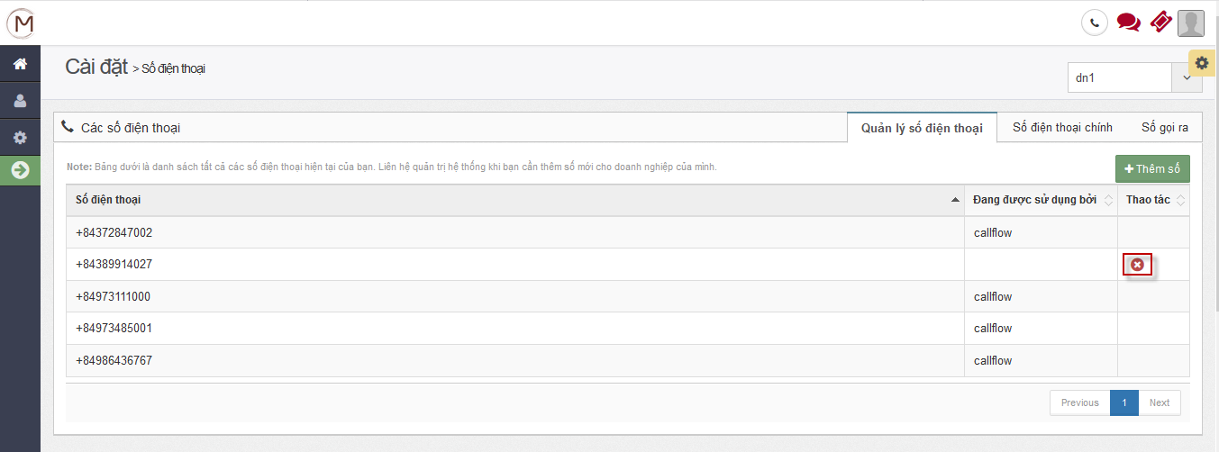

* It shows a confirm:

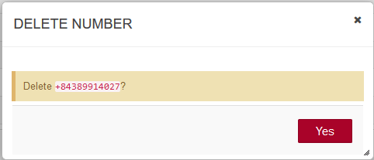

* Step 2: Click “Yes” button to delete.

#### Number Management – log in with an enterprise admin account

* When logging in with an enterprise admin account, the system only displays the phone number list of the respective business, does not display the "Add new" button.
* - Adding a new phone number of an enterprise only has an account with Superadmin permissions.

### Tab “Main Phone numbers”

* The function allows users to assign / remove phone numbers to the main phone number list of the business
* Users with Super admin or an enterprise admin account have the right to perform this function
* The following only describes instructions for user as an enterprise admin account. Super admin only need to add a business selection step before configuring.

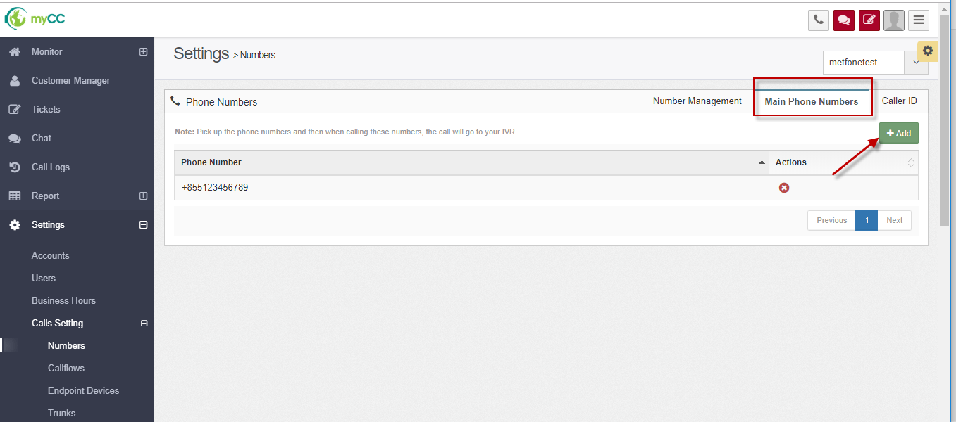

### Tab “Caller ID”

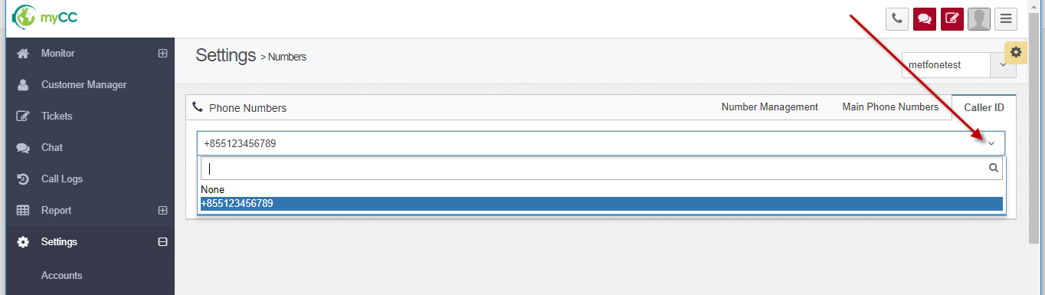

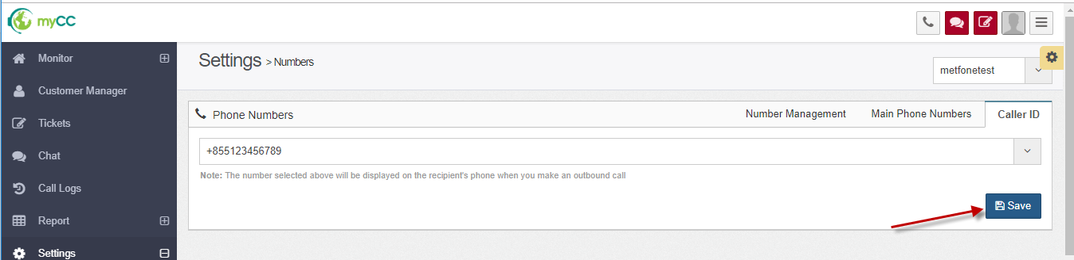

The number selected above will be displayed on the recipient's phone when you make an outbound call.

## Configure device for users (Endpoint devices)

### Configure device information on the web

* Choose from the menu: Settings/ Calls setting/ Endpoints device:

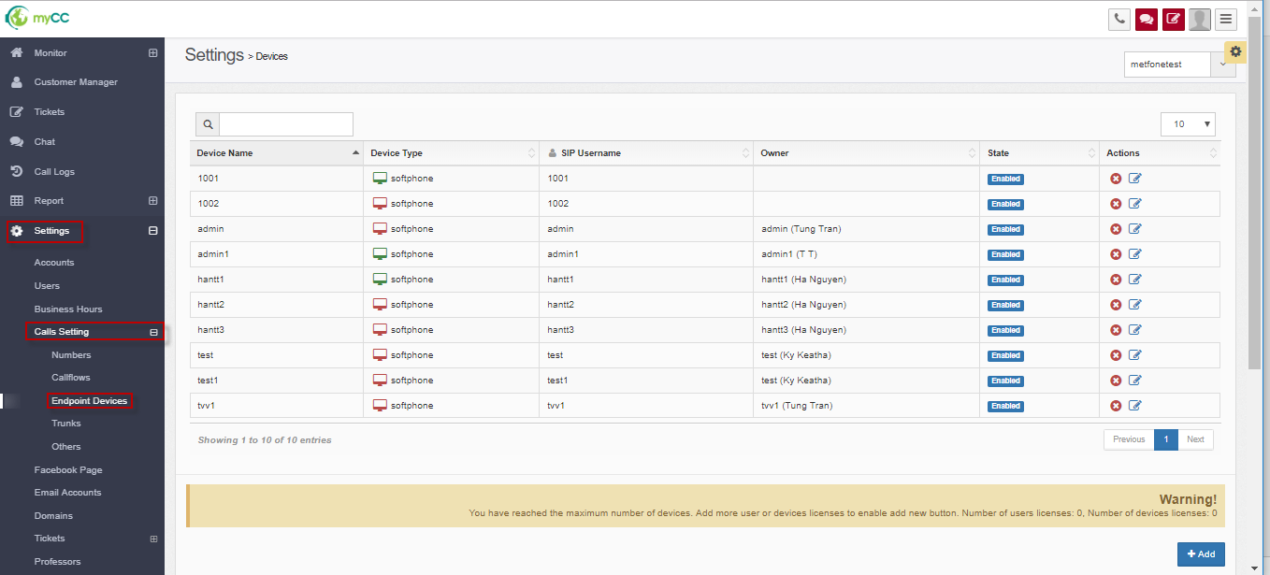

#### Add new devices

* Step 1: Click “Add” button:

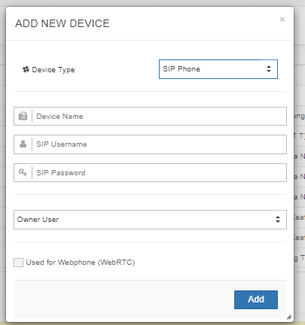

* Step 2: Enter information:
  + Device type:
    - Default value: SIP Phone : it means : you can use softphone or webphone or IP phone device to make or receive a call.
  + Device Name (*): should always set the Agent's username to search for ease
  + SIP Username (*)
  + SIP Password (*)
  + Used for webphone (WebRTC)
* If the checkbox is selected: Agent will receive the call directly on the Web, no need to install additional Softphone such as 3CX, X-lite or use IP Phone device
* If the checkbox is not checked: additional settings are required for the Agent Softphone or IP Phone to receive calls
* Step 3: Click button **“Add”** .

#### Update devices

* Step 1: On device configure screen, click icon Update:

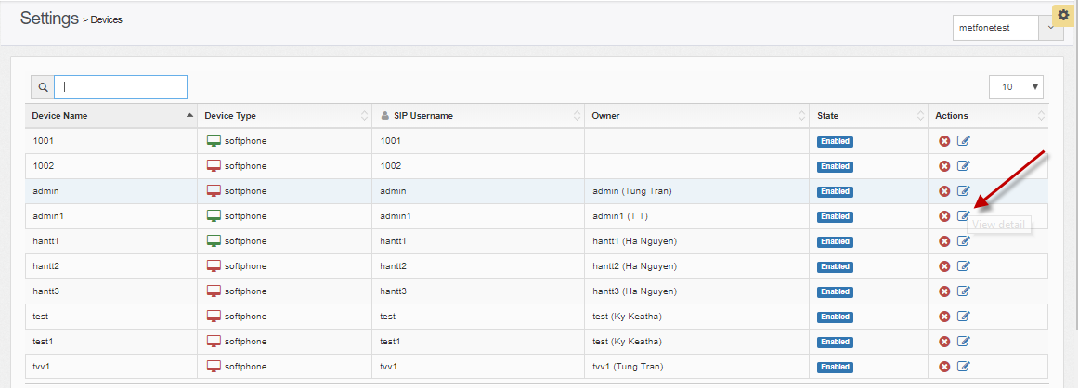

* It shows:

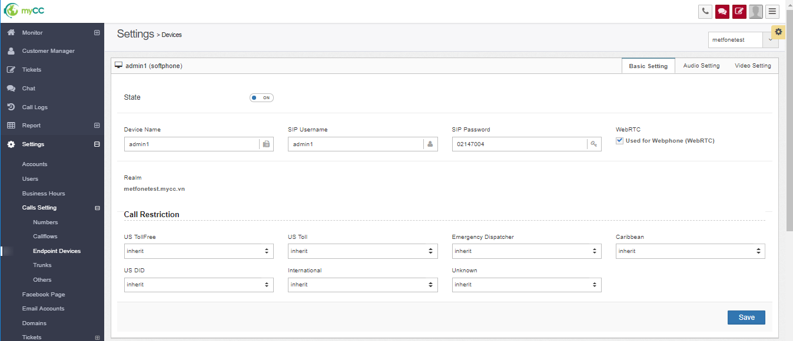

* + The default displays the "Basic Configuration" tab:
  + Realm: information cannot be changed, it is generated when creating the device, this parameter is used to configure at SIP IP when you want to receive calls on Softphone or IP Phone
  + ▪Device name, SIP Username, SIP Password, WebRTC: you can edit

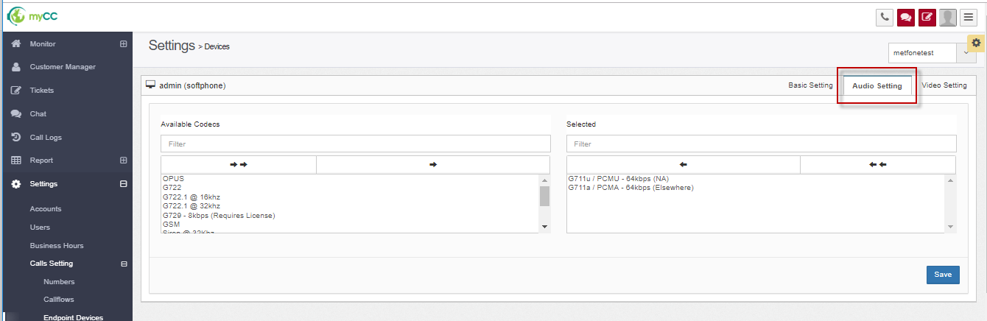

* + When clicking on the "Audio setting" tab: the default system generates the code to receive normal voice calls , do not change in this tab

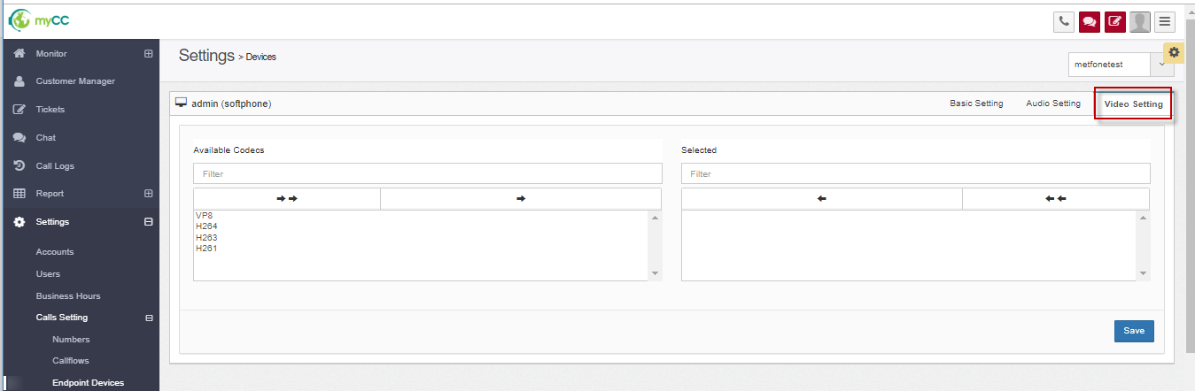

* + When clicking on the "Video Settings" tab: users can configure the code to allow the agent to receive video calls. Agent wants to receive video call, need to select at least 1 code (Example: VP8)
* Step 2: Users can edit information (if necessary) at the tabs: Basic Setting, Audio Setting, Video Setting.
* Step 3: Click button **“Save”.**

#### Delete devices

* Step 1: On list devices screen, click icon Delete at which device you want to delete.

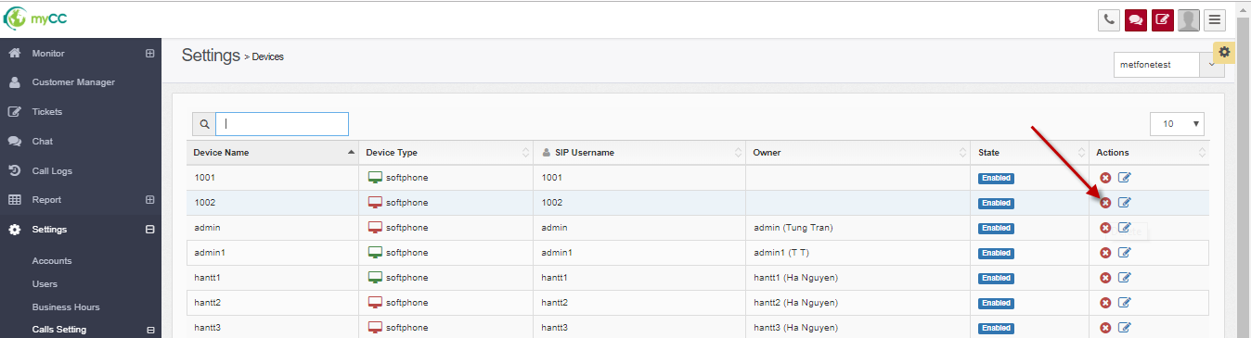

* It shows a confirm:

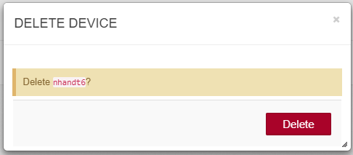

* Step 2: Click button **“Delete”**.

### Config IP Phone device

* Example: IP PHONE – Grand Stream GXP1610/1615

After plugging in, connecting to the network, the IP Phone screen displayed:

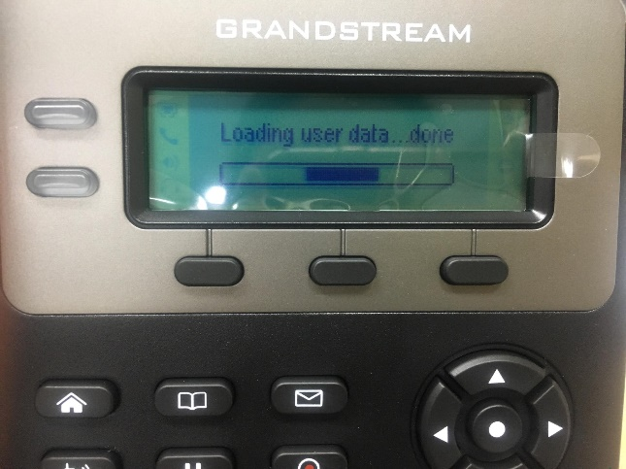

Then:

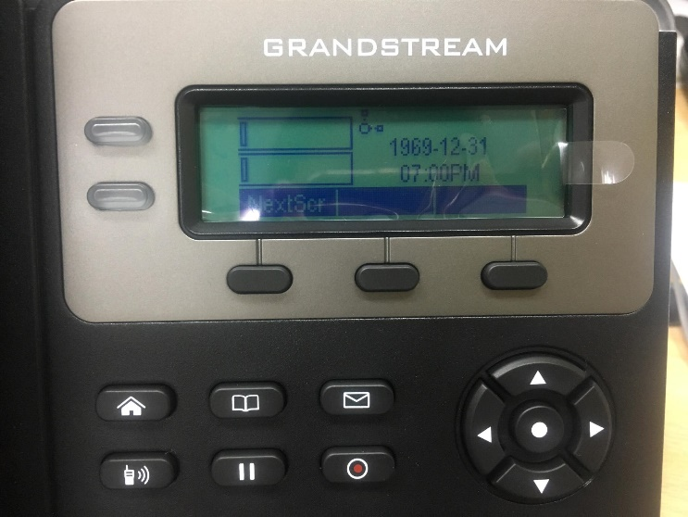

Press Menu button (middle button of circle):

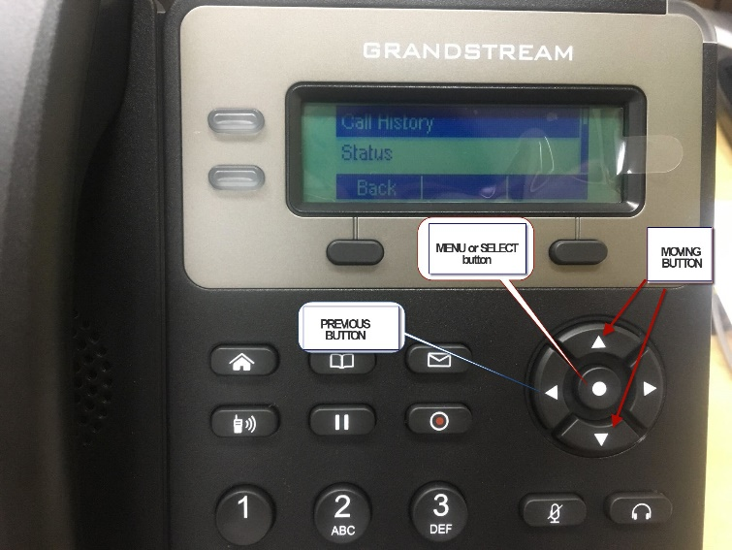

List options: Call History, Status, Contacts, Messages, Preference, Direct IP Call, Phone, System, Reboot.

Moving to Phone option: 🡪 press Select button 🡪 it shows options: SIP, Call Features.

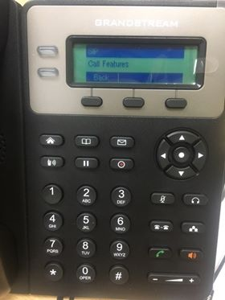

Choose SIP 🡪 it shows : Account 1: (Not Registerd).

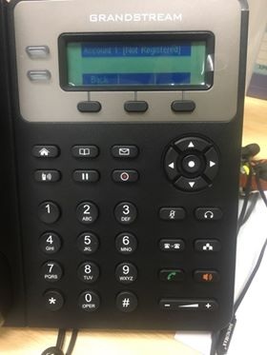

Choose Account 1: (Not Registerd) 🡪 it shows: Sip Proxy, Outbound Proxy, User ID, Auth ID, Password, Transport, Audio.

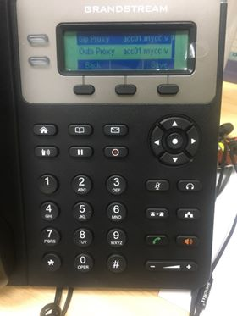

Click to select each value to enter the information :

(get information from the configured Device Details screen on the Web)

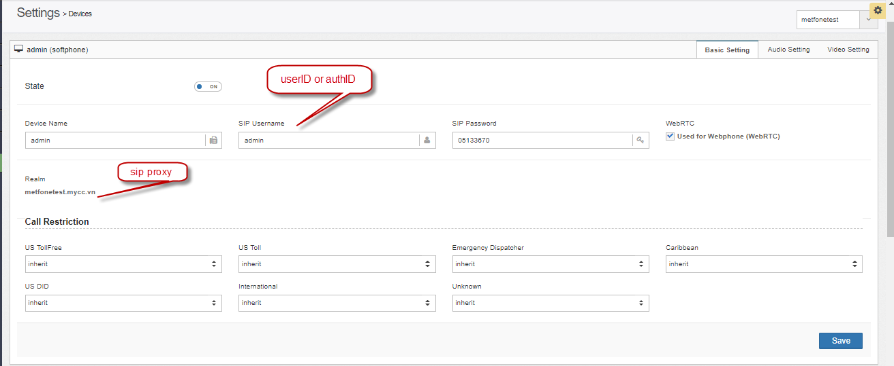

* Sip Proxy : input Realm information:

example: metfonetest.mycc.vn

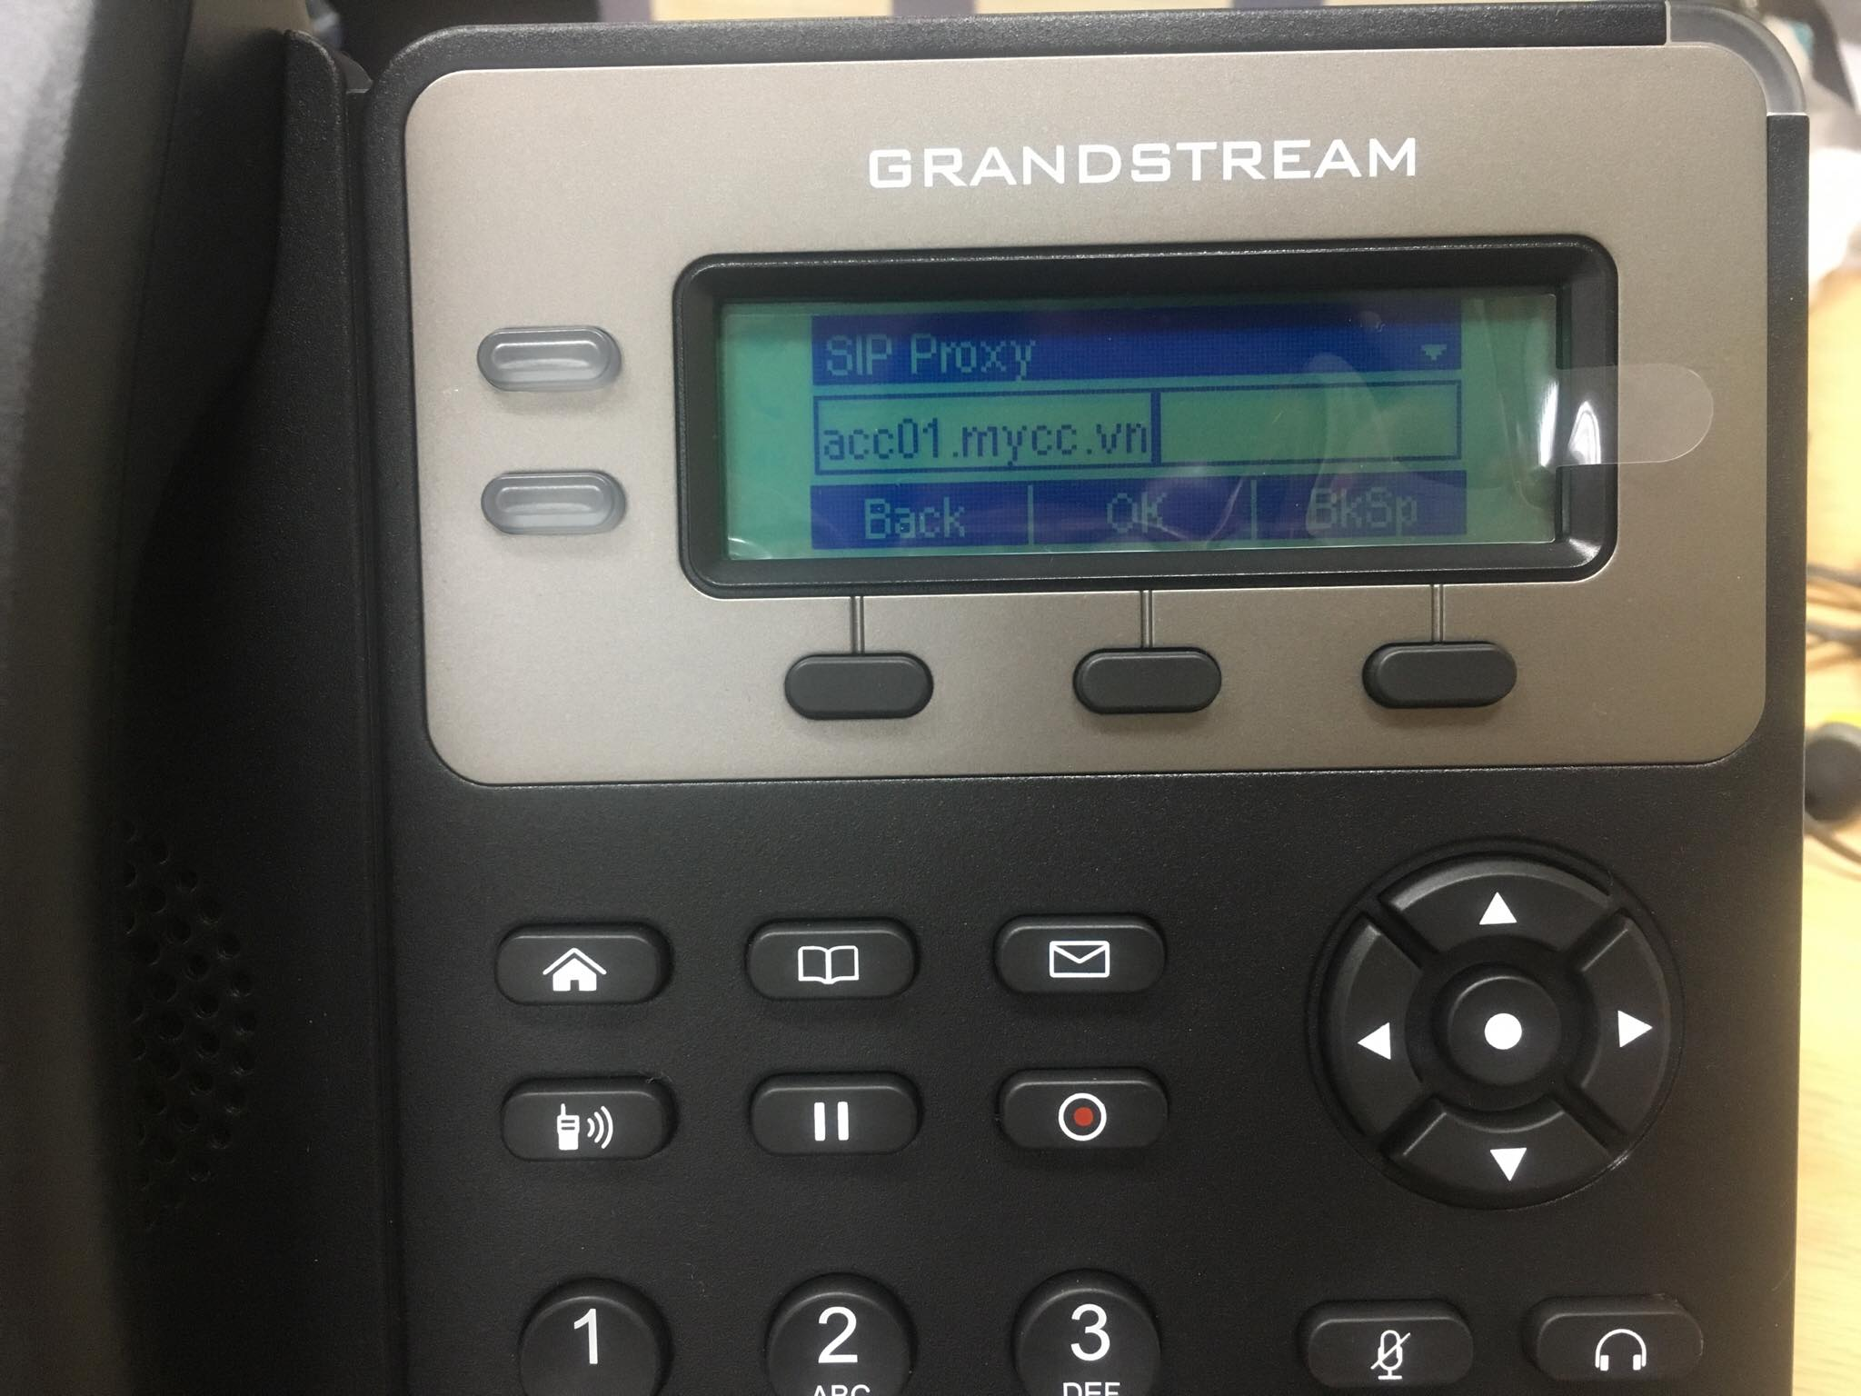

Press button OK to save information 🡪 press the left button of the circle to return to the previous menu, press the up and down buttons to select the next values of the category 🡪 enter information.

* Outbound Proxy : let it null
* User ID : ~~ sip username, exp: 1006
* Auth ID : ~~ sip username, exp: 1006
* Password : input device’s password:
* Transport: default: UDP
* Audio: default: PCMU

Note: after entering the value in each step, you need to press the OK and Save buttons.

The sign * replaces the dot character.

To enter an alphabetic character, press the corresponding numeric character multiple times.

After entering all the above information, return to the main menu 🡪 click Reboot 🡪 Reboot the device.

### Configure with 3cx softphone

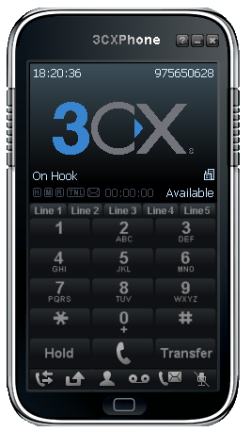

Right-click the screen area, select Accounts:

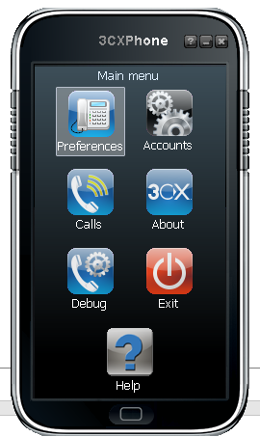

It shows:

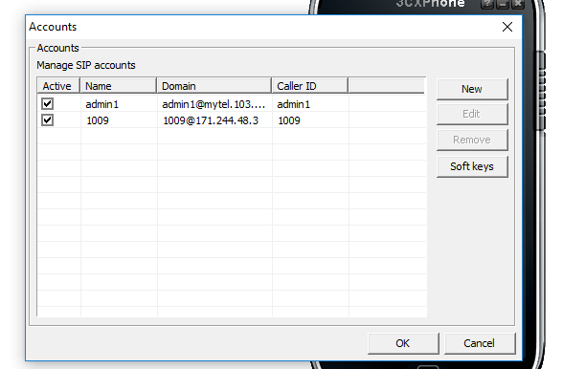

Click the New button, enter the following parameters:

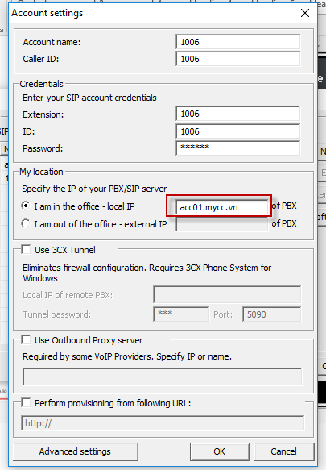

* + At IP text: Enter the data that matches the Realm generated information when creating the device for the user:

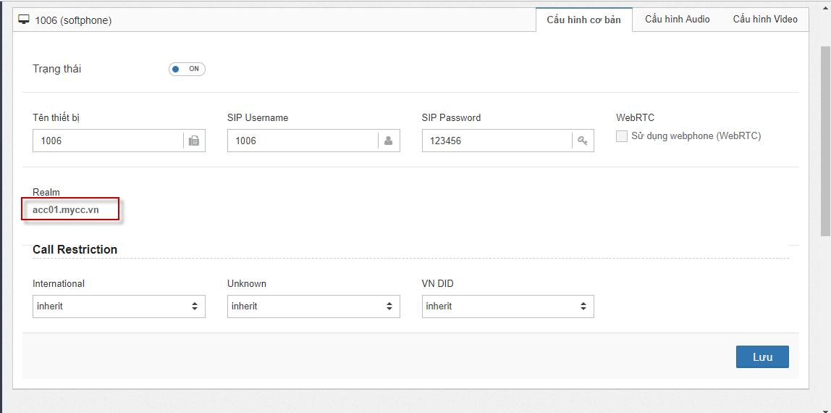

If you configure successfully, 3cx show On hook on the screen.

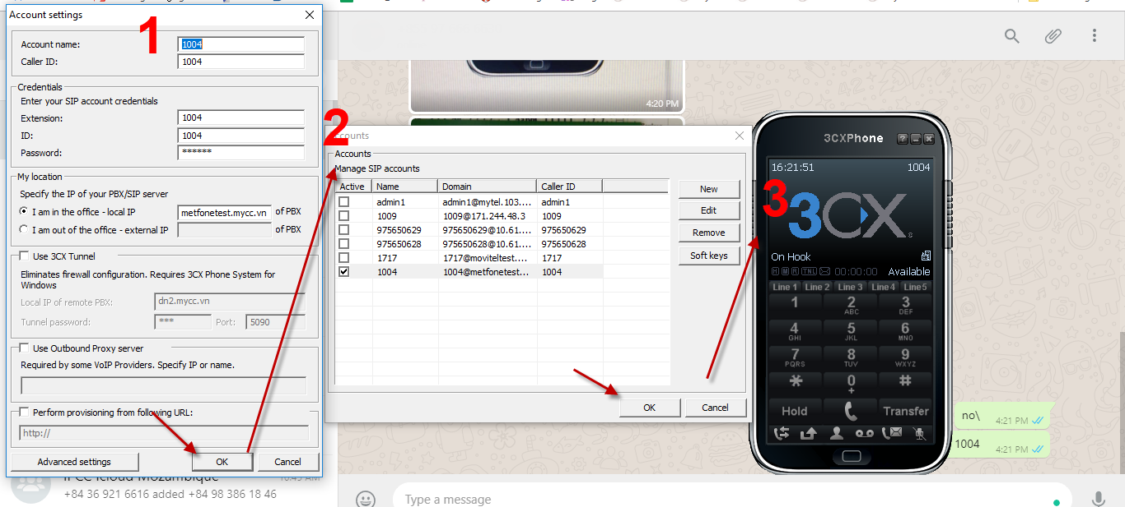

## Configure Callflows (Voice Inbound)

The function allows to configure the call flow for businesses. Includes: Configuring inputs for Callflow: Media, Menu, Queues , call time; others for businesses.

On each branch of Callflow, you can configure call route to:

o Menu: play media file, and require the customer press key to go to the next processing.

o Media: just play file, not press key.

o Specific Agent

o Queue

o Other callflow

Customers call bussiness’s phone number, the system will process according to the corresponding callflow configuration, within the configured time.

Each business can configure many different numbers, which can be applied with the same or different callflow.

### Media

* The function to upload media files, used for ringback tones in Queue, ringback tones when Agent hold call.
* From left menu, choose Settings/ Calls setting/ Othes 🡪 click on Media tab:

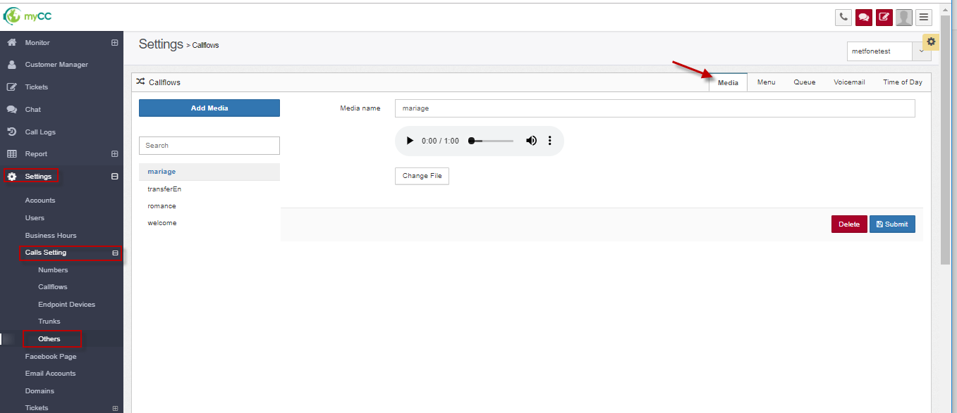

#### Add new media

* Step 1: Click Add media button:

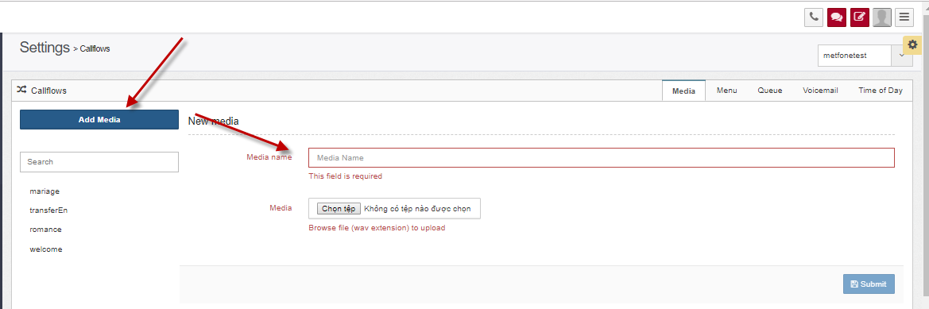

* Step 2: Input information:
  + Media name (*)
  + Media (*): choose the wav file.
* Step 3: Click button **“Submit”** to save media.

#### Update media

* Step 1: Choose one media 🡪 it shows:

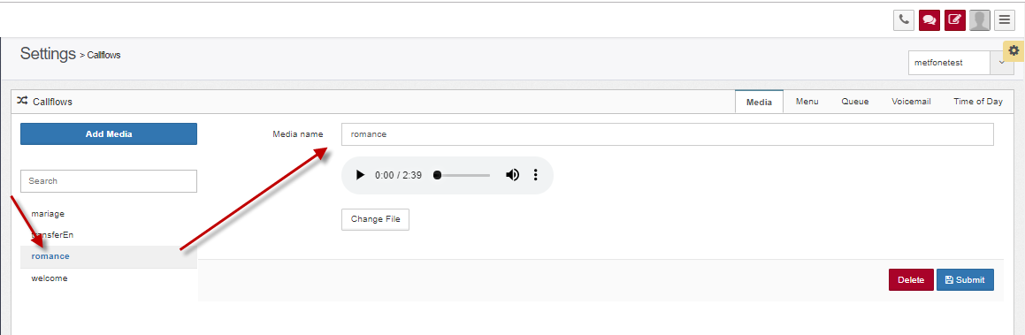

* Step 2: Change information:
  + Media name
  + Media: change wav file.
* Step 3: Click button **“Submit”** to save.

#### Delete media

* Step 1: Choose one media:

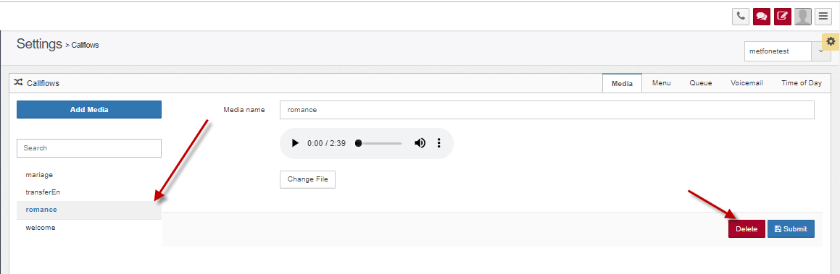

* Step 2: Click button **“Delete”**.

### Configure Menu

* Menu is the input to configure Call flow, which has a media file, and allows keystrokes to go to the next processing.
* From left menu, choose Settings/ Calls setting/ Othes 🡪 click on Menu tab.

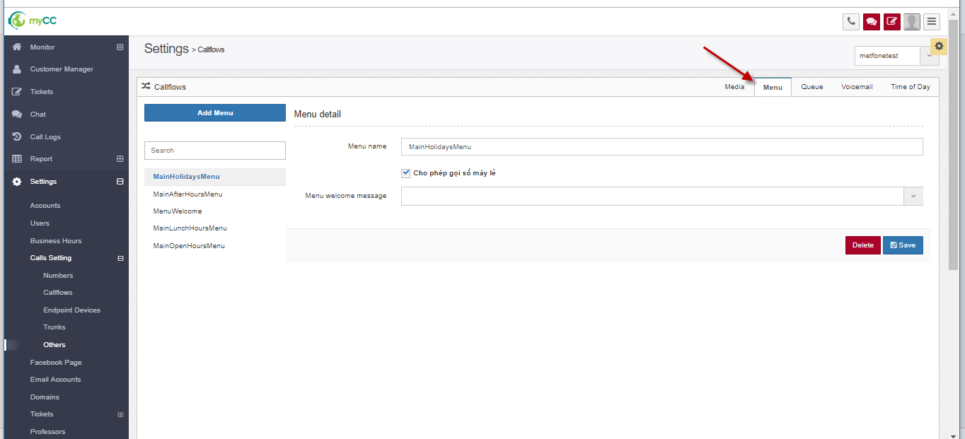

* For each business account, the default system has menus:
  + MainHolidaysMenu
  + MainLunchHoursMenu
  + MainAfterHoursMenu
  + MainOpenHoursMenu

#### Add new Menu

* Step 1: From Menu setting, click “Add menu” button:

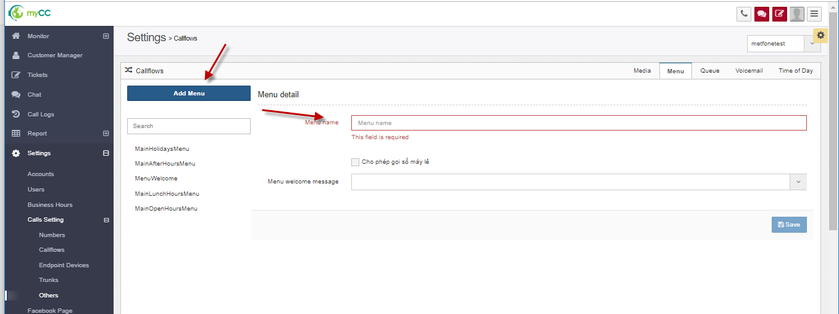

* Step 2: Input information:
  + Menu name (*)
  + Menu welcome message (*): choose one value of Media
* Step 3: Click button **“Save”** .

#### Edit Menu

* Step 1: Choose one menu from list menus, it shows like that:

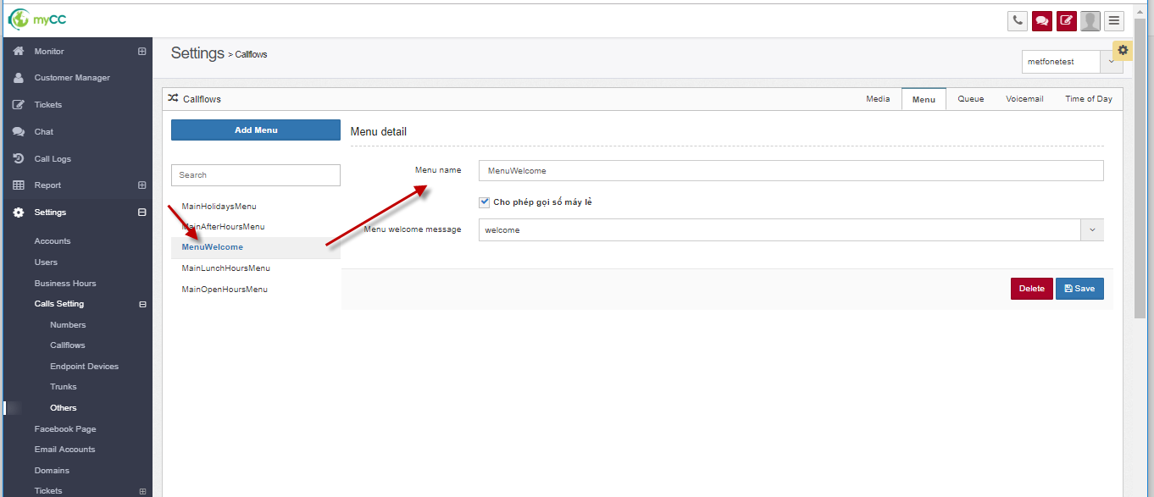

* Step 2: Change information:
  + Menu name:
  + Menu welcome message
* Step 3: Click button **“Save”** .

#### Delete Menu

* Step 1: Choose one menu from list menus:

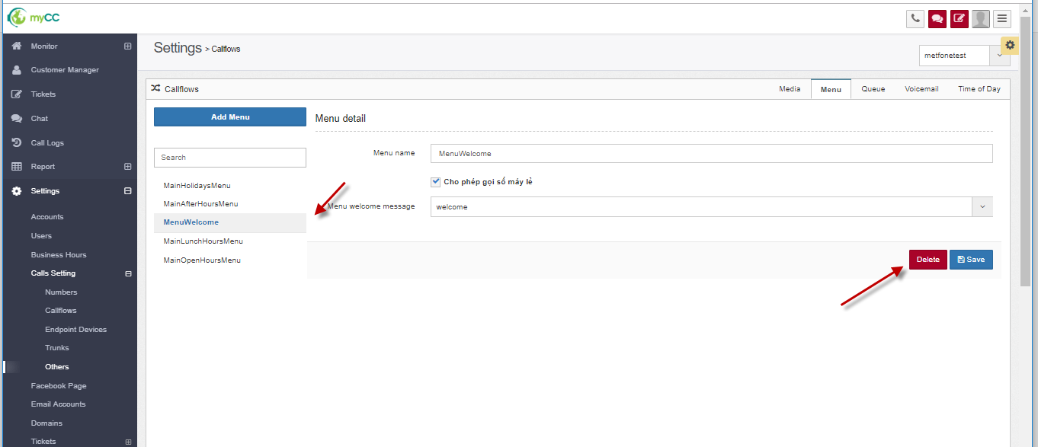

* Step 2: Click button **“Delete**.

### Queues

* Queue configuration to receive inbound calls. When customers call the system, choose to meet the Agent, the call will be routed to an Inbound Voice Queue corresponding to the service selected by the customer. From here, the system will search for the free Agent assigned to this Queue to allocate the call.
* From left menu, choose Settings/ Calls setting/ Othes 🡪 click on Queue tab.

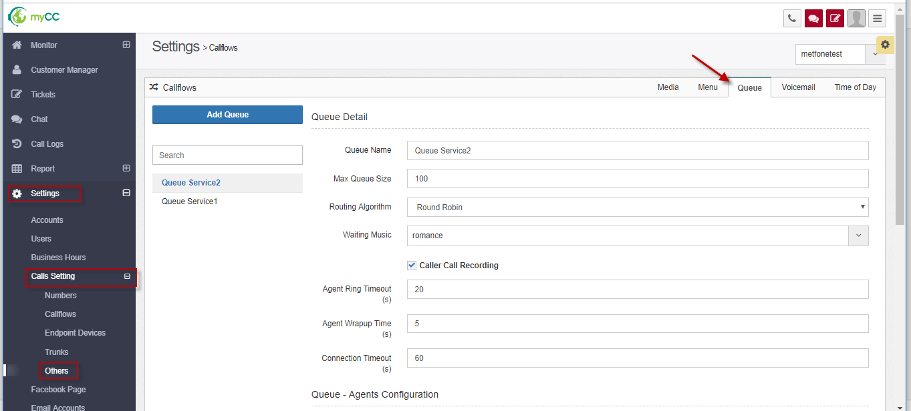

The screen is showed like that:

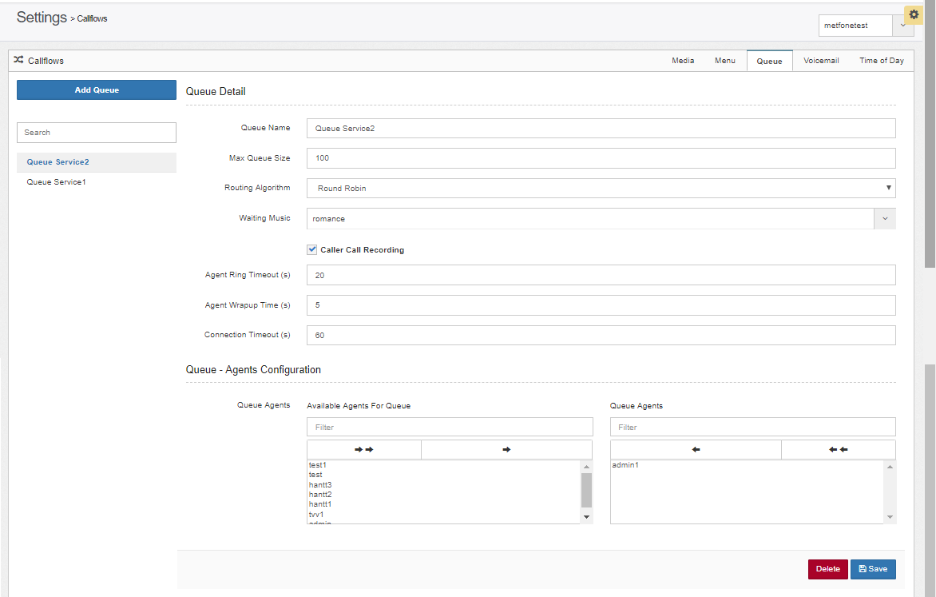

#### Add new Queue

* Step 1: From tab *“Queue”*, click button **“Add Queue”:**

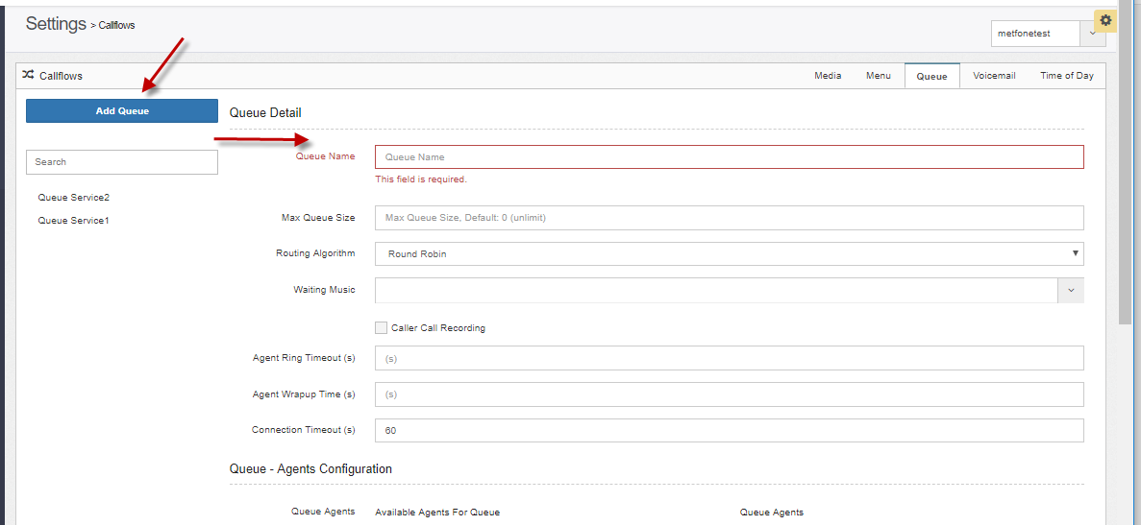

* Step 2: Input information:
  + Queue name (*)
  + Maximum number of calls: currently the system has not applied this parameter
  + Algorithm: choose Rotate (Round robin) or Longest free (Most Idle)
  + Default value: Rotate
    - " Rotate " algorithm: the system that distributes calls by the time the call is allocated to the Agent, prioritizes which Agent in the previous times received the call before the other Agents.

For example, in Queue there are 3 agents: Agent1, Agent2, Agent3.

At 1st time: Call distributed to the agent in order: Agent1, Agent2, Agent3.

For the next time, the call is also distributed in the following order: Agent1, Agent2, Agent3.

* + - “Most idle” algorithm: is the allocation algorithm according to the end of the previous call of each agent, prioritizing which agent is the longest available.
    - For example, in Queue there are 3 agents: Agent1, Agent2, Agent3.
    - The call is distributed in order: Agent1, Agent2, Agent3.
    - Calls have an end time in order: Agent2, Agent3, Agent1.
    - The next time the calls will be allocated to the agent in order: Agent2, Agent3, Agent1
  + Waiting music: choose one value from list media file.
  + Caller Call Recording: When checkbox is checked, the system will record the customer since entering Queue, the previous sections are configured in the "Enterprise configuration" function - "Recording settings"
  + Agent ring timeout (s): The maximum time in each ring of the call to the agent, the agent who does not pick up the call will return to Queue looking for another free agent.
  + Agent Wrapup Time (s): The agent's vacation time after the call ends, after this time, the agent is free to receive the next call.
  + Connection Timeout (s): timeout in Queue, queue customers after this time without any agent in Queue received, the call will be terminated
  + Queue – Agents configuration: Users can assign agents to Queue, or they can be assigned after the Queue has been created.

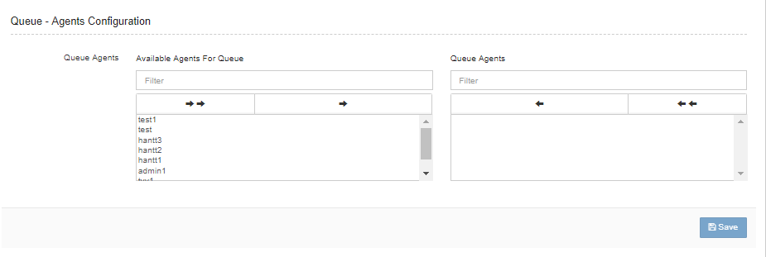

* + - Assign agents to Queue:
      * User can select agent in left frame: choose 1 (), choose all () or choose Multiple by press: Shift, Ctrl
      * Remove agent from queue : choose agents from right frame and click icon to remove: choose 1 (), choose all (), or choose multiple to remove .
* Step 3: Click button **“Save”** .

#### Update Queue

* Step 1: Choose one queue from list queues , it is showed : Queue Detail:

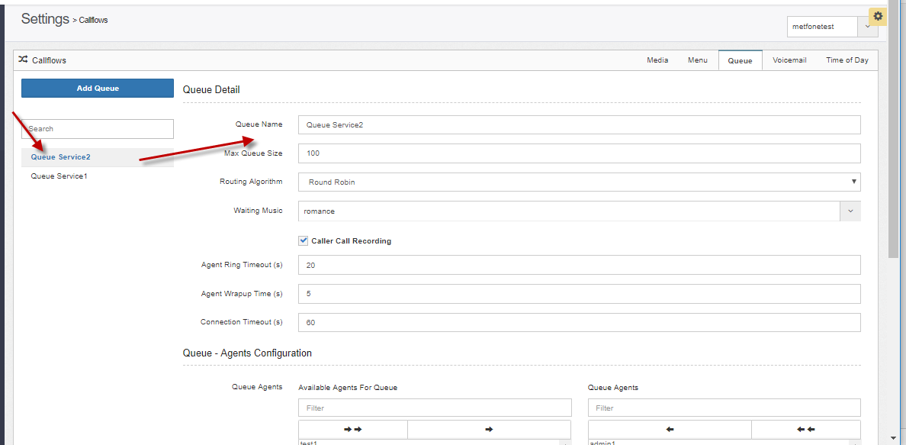

* Step 2: Change information
* Step 3: Click “Save” button.

#### Delete Queue

* Step 1: Choose one queue from list queue
* Step 2: Click “Delete” button.

### Configure Time of Day

* The function allows to configure the working time of the business. The time can be configured for the IVR and ACD numbers or for each individual queue.
* Types of time include: During working hours, Outside working hours, Lunch break, Holidays.
* This is the input for configuring the uptime of the business (configuring call flow), for IVR numbers or Queues that do not work 24/7.
* From left menu, choose Settings/ Calls setting/ Othes 🡪 click on Time of Day tab

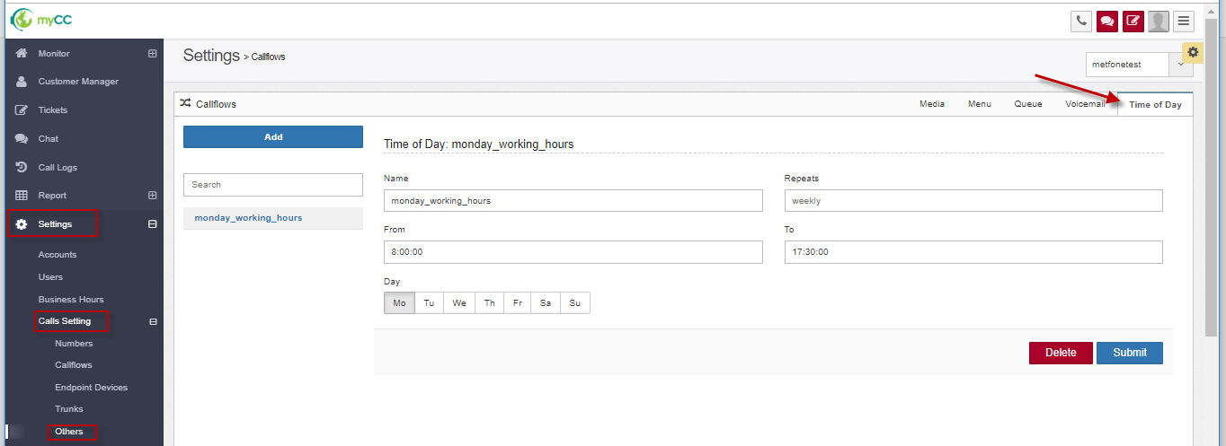

#### Add new

* Step 1 : From Time of Day screen, click “Add” button, it shows like that:

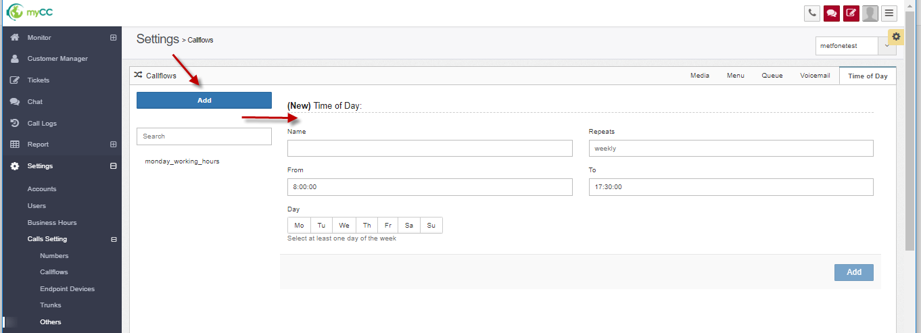

* Step 2: Input information:
  + Name (*)
  + Repeats: default: weekly
  + From: HH24:mi:ss
  + To: HH24:mi: ss

( Default: From 08:00:00 To 17:30:00)

* + Day (*)
    - Choose value from: Mo, Tu, We, Th, Fr, Sa, Su (corresponds to the things of the week)
    - At least choose one day.
* Step 3: Click “Add”button.

#### Edit time of day

* Step 1: Choose one value from list config time of day:

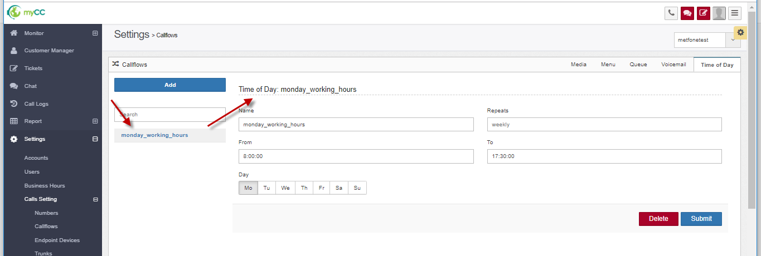

* Step 2: Change information
* Step 3: Click “Submit” button to save.

#### Delete time of day config.

* Step 1: Choose one value from list time of day config:
* Step 2: Click “Delete” button.

### Configure Callflow

* After configuring the inputs such as Media, Menu, Queue, Time of Day -> Admin can configure Callflow for businesses.
* From left menu, choose Settings/ Calls setting/ Callflows

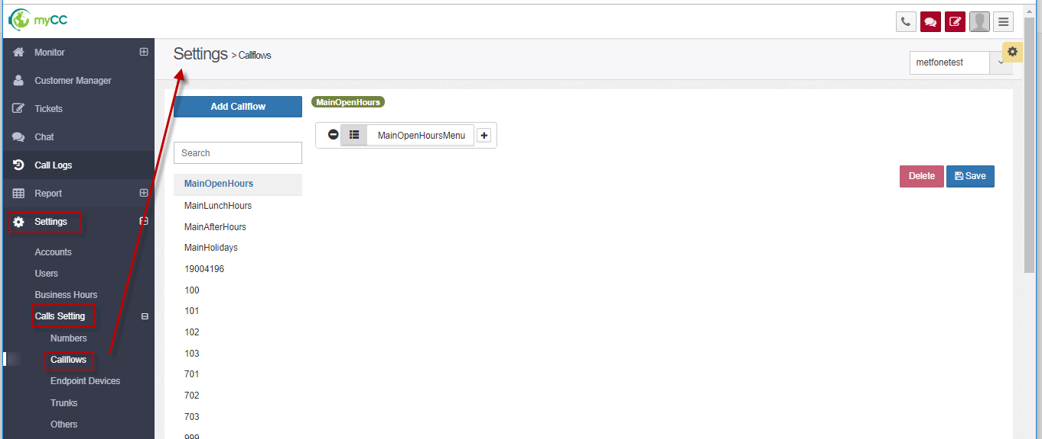

It shows:

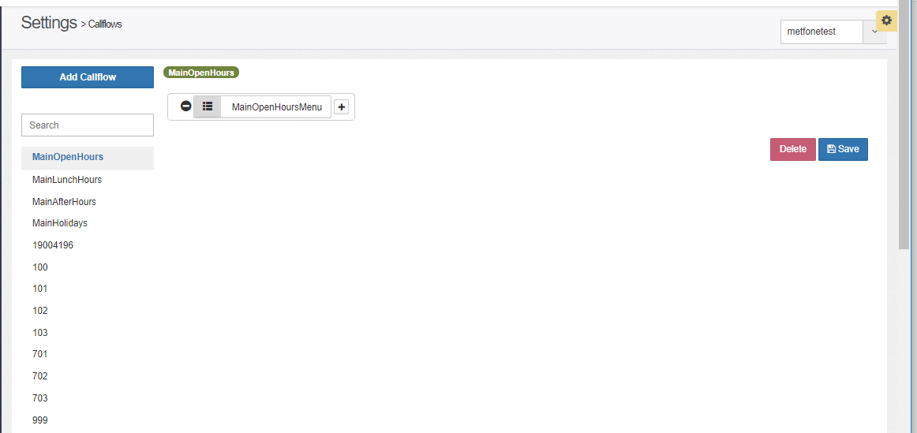

* For each business account, the default system has the following callflows:
  + MainOpenHours
  + MainLunchHours
  + MainAfterHours
  + MainHolidays

#### Add new Callflow

* Step 1: From Callflow setting, click “Add Callflow” button:

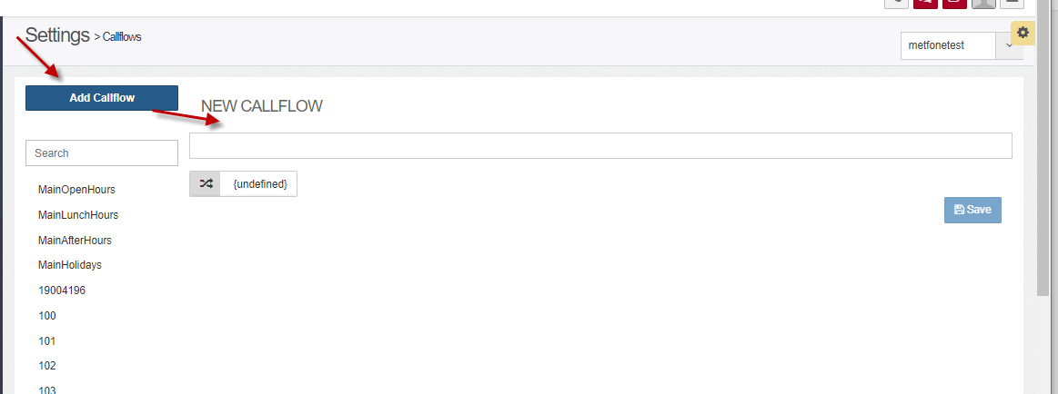

* Step 2: Input information:
  + Name of Callflow (*)
  + Destination moved (*): choose destination from this control 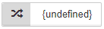
    - Click button  🡺 it shows:

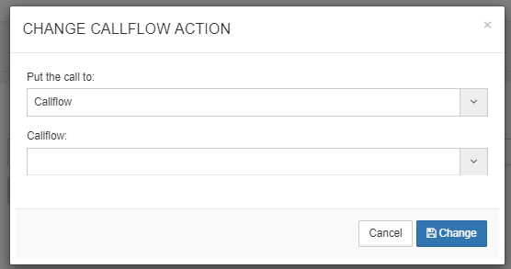

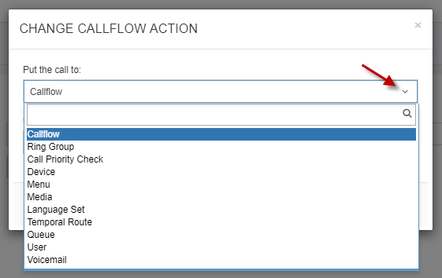

* + - Users select destination type to move to the Call divert box. Include:
      * Callflow: switch to another Callflow
      * Device: move to specific agent under Device
      * Menu: switch to the menu (The menu has media playback and allow to select the key to go to other processing)
      * Media: play media files
      * Language Set: allows setting language
      * Temporal Route: when you need to configure the working time for IVR or the ACD branch to work 24/7: Temporal Route should be selected to configure
      * Queue: transfer to Queue
      * User: allows to transfer to specific Agent by username
      * The user switches to a specific destination after selecting the destination type (For example: after selecting the type of Queue, which one should be selected)
    - Click the "Change" button on the popup Select the callflow to make the selection
* Step 3: Click “Save”
* Note:
  + *A phone number is assigned to the main phone number of the business (in the "Phone Number Configuration")*
  + *Customer calls this number: the default call will follow MainOpenHours callflow*

*An enterprise can configure a number or multiple numbers.*

*▪ Different numbers can point to a callflow: for quick configuration, add these numbers to the main phone number of the business.*

*▪ Different numbers of heads pointing to different callflows: need to declare more callflow associated with this number in the callflow section*

* + *For example: Enterprises have 2 numbers: 1062, 02466522614*

*Customers call up to process according to 2 different callflows that can be assigned 1062 to the main phone number (number 02466522614 only created in the phone number), create 1 callflow +842466522614 in the callflow function*

*➔ customers call to 1062 to handle MainOpenHour callflow, customers call up 02466522614 processing according to callflow +842466522614*

#### Edit Callflow

* Step 1:On tab*“Callflow”*, choose one callflow 🡺 it shows:

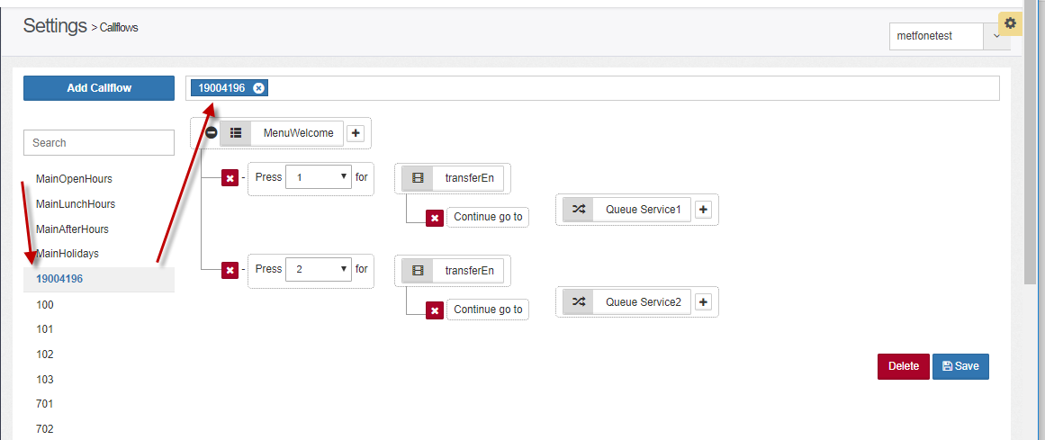

* Step 2: Change information
* Step 3: Click Save

#### Delete Callflow

* Step 1: Choose one callflow which you want to delete.
* Step 2: Click “Delete” button

## Configure Email Account

* The function allows to configure the address of receiving emails of customers sent to businesses.
* All emails sent by the client are retrieved to the myCC system, sent to the email queue -> the system automatically allocates to the counselors according to the rotation algorithm.
* From menu, click:

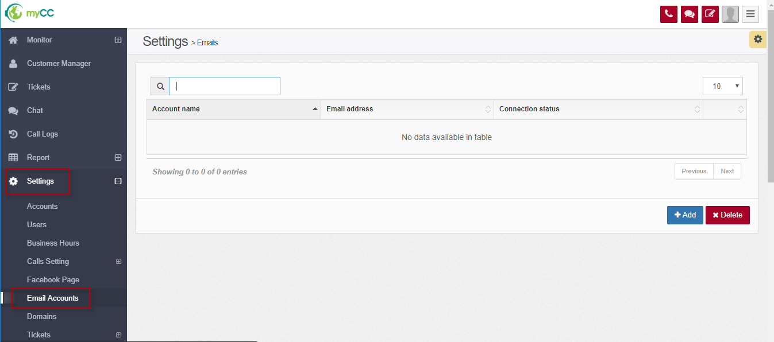

#### Add new email account

* On the email accounts setting, click “Add” button, it opens a popup:

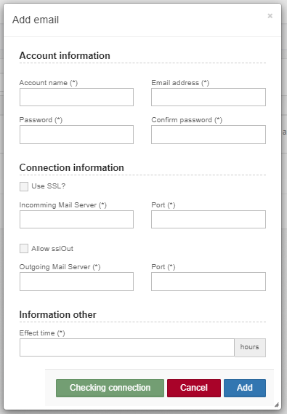

* Input information:

Account name (*)

Email address (*)

Password (*)

Confirm password (*)

Checkbox use SSL? Incomming Mail server (*) / Port (*)

Checkbox allow SSLOut ? Outgoing mail server (*) / Port (*)

Information other / Effect time (*)

* Click “Add” button to save.
* Click “Checking connection” to check.

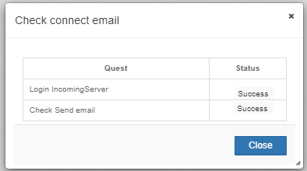

* If status is success 🡪 configure completely, can use this email account.

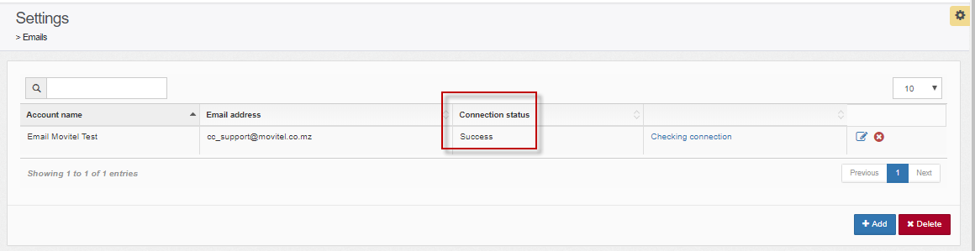

#### Edit Email account

* On email account setting screen, click icon Update email :

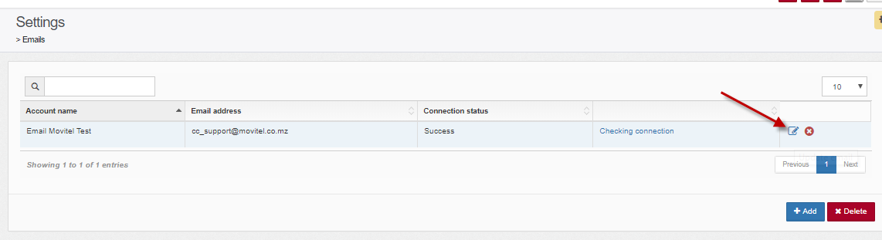

* It shows:

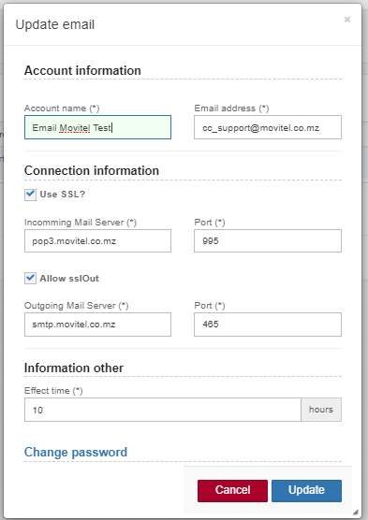

* Step 2: Change information
* Step 3: Click “Update” button.

#### Delete Email account

* On email account setting screen, click icon Delete email:

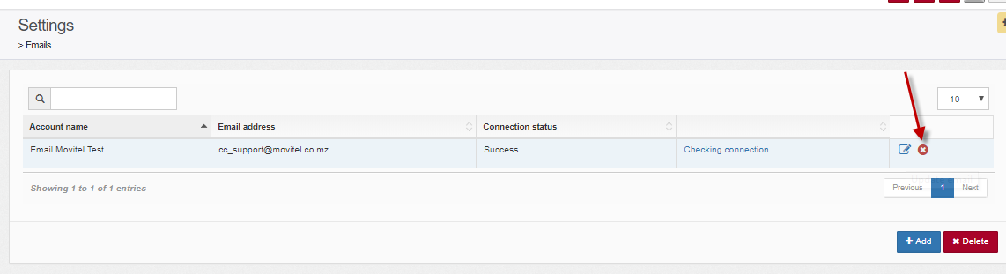

* It shows a confirm:

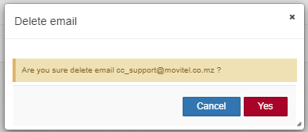

* Step 2: Click button “Yes” to delete.

## Configure Domains (chat)

* Function to enable chat site configuration. Customers send chat via web chat channel - the transaction is waiting in Queue.
* The system automatically allocates email to agents according to the rotation algorithm.
* From menu, click Settings/ Domains:

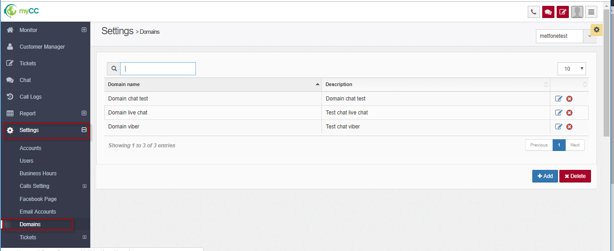

### Add new domain

* The function allows to declare general information of the website, including: Name, Description
* From Domain settings, click “Add” button:

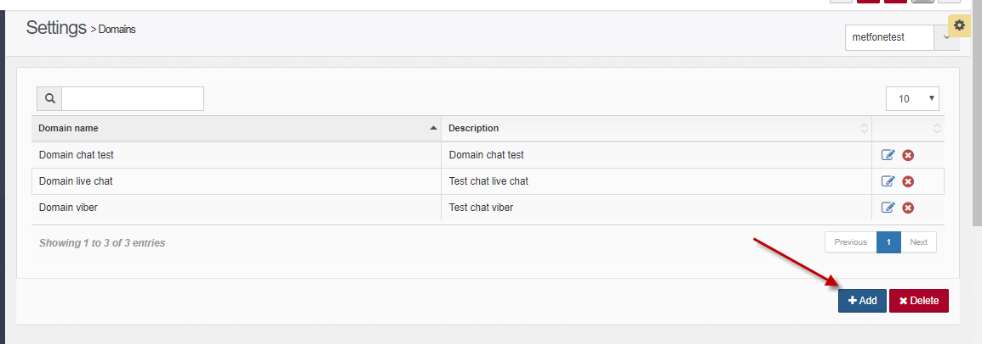

* It shows:

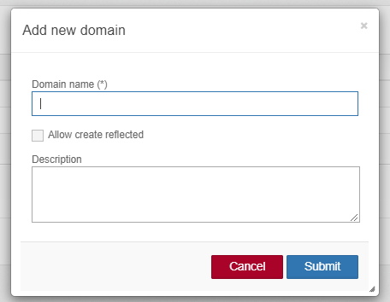

* Step 2: Input information:
  + Domain name (*)
  + Description:
  + Note: checkbox: Allow create reflected: do not care
* Step 3: Click button **“Submit”.**
* After adding the website successfully, it is necessary to configure the next tab: Display configuration and Enter information.

### Edit Domain

* Step 1: On list domains, click Edit icon:

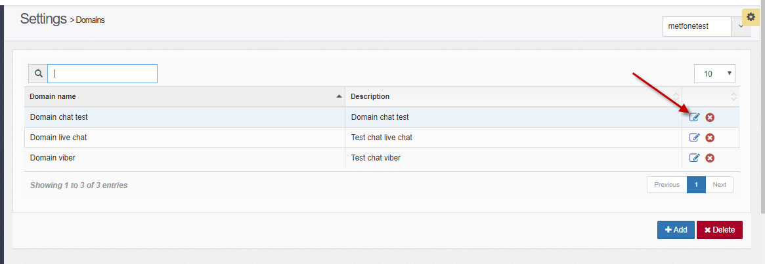

* The screen shows:

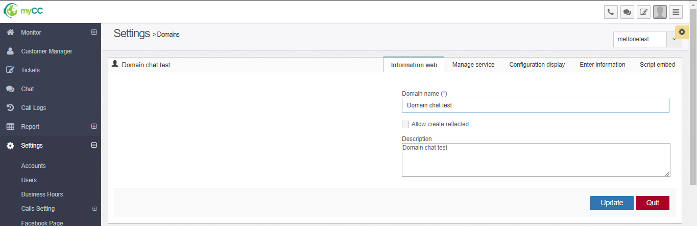

#### Tab Information web

* Allow users to update information name, website description

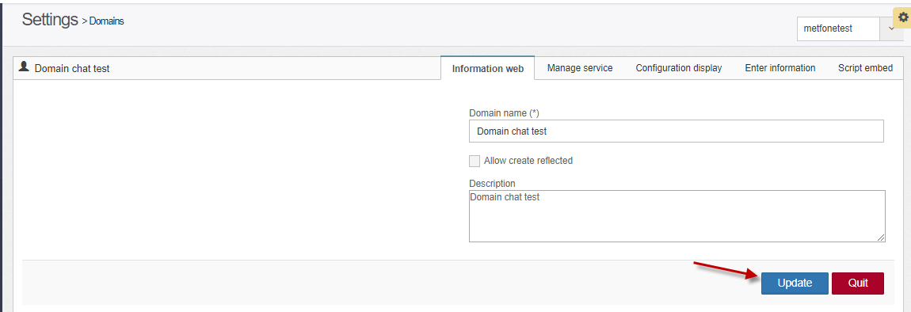

#### Tab Manage service

* Allow to add / edit / delete services for the website.
* When adding a new domain, by default, the system generates a service itself. Admin can also declare additional services.

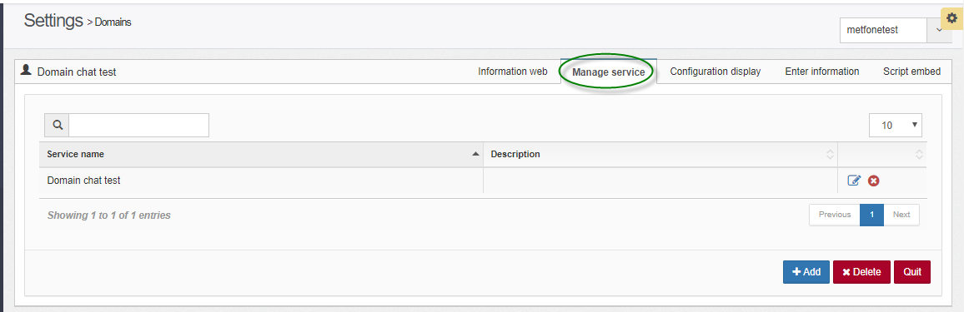

* + Domains with only 1 service -> Customers who chat on the web will not have to choose the service
  + For domains with many services -> Web chat customers must choose the service
* **Add new service**
  + From Manage service screen, click Add button:

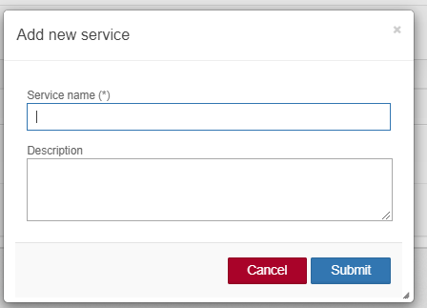

* + Input information:
    - Service name (*)
    - Description
  + Click “**Submit”**
* **Edit service**
  + On Manage service screen, click icon at which line you want to edit:

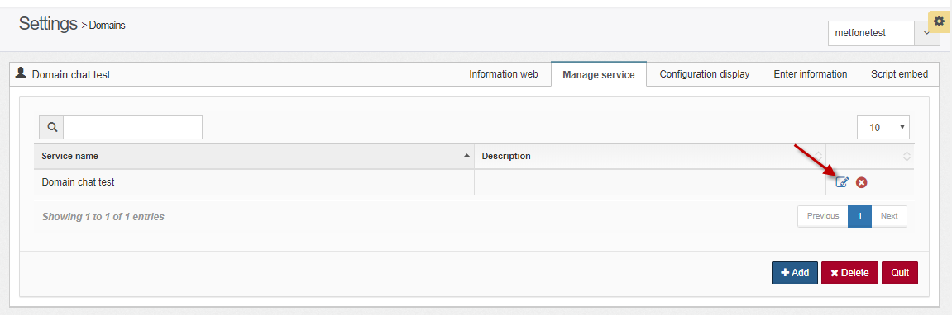

* It shows:

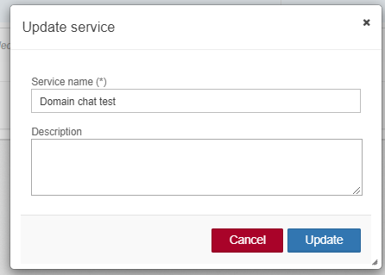

* + Chane information
  + Click “Update” button
* **Delete service**
  + Click icon Delete at which line you want to delete

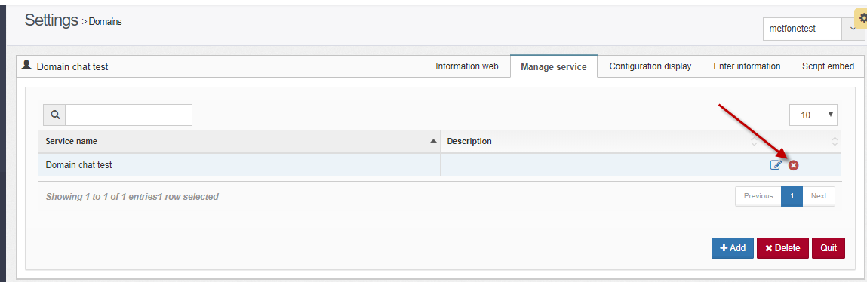

* It shows:

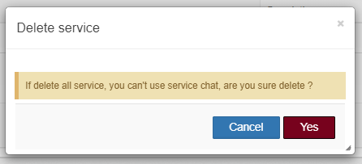

* + Click “**Yes**” to delete.

#### Tab Configuration display

* Allow to configure the information displayed on the chat window such as: Title, Color, Support staff, Language.

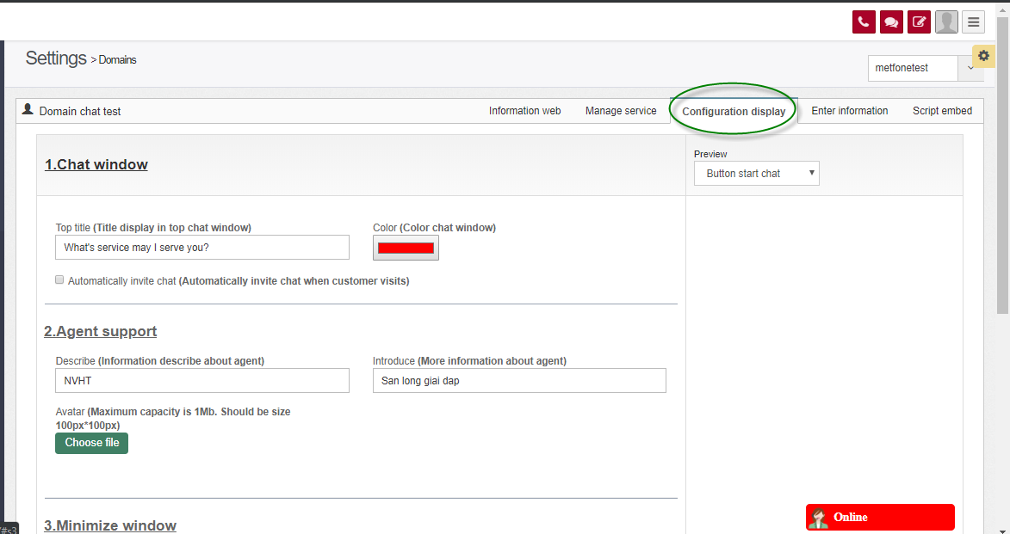

* Click icon to view Chat window:

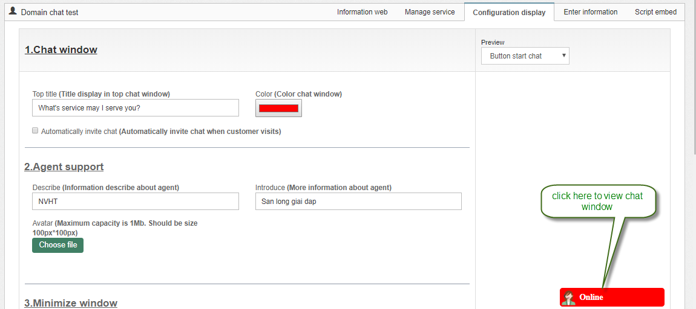

* It shows like that: (window for customers to chat to the system)

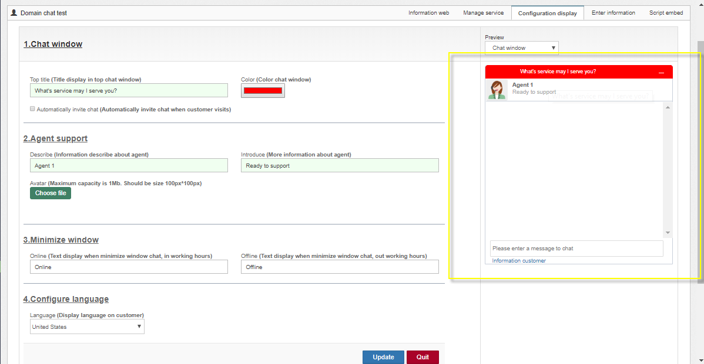

#### Tab Enter information

* Allow to configure information as: Customer greetings when the customer starts chatting, the message informing the chat transaction is finished, the time to alert when the customer leaves for too long does not respond to the agent, the scene message report when the customer left too long without feedback agent

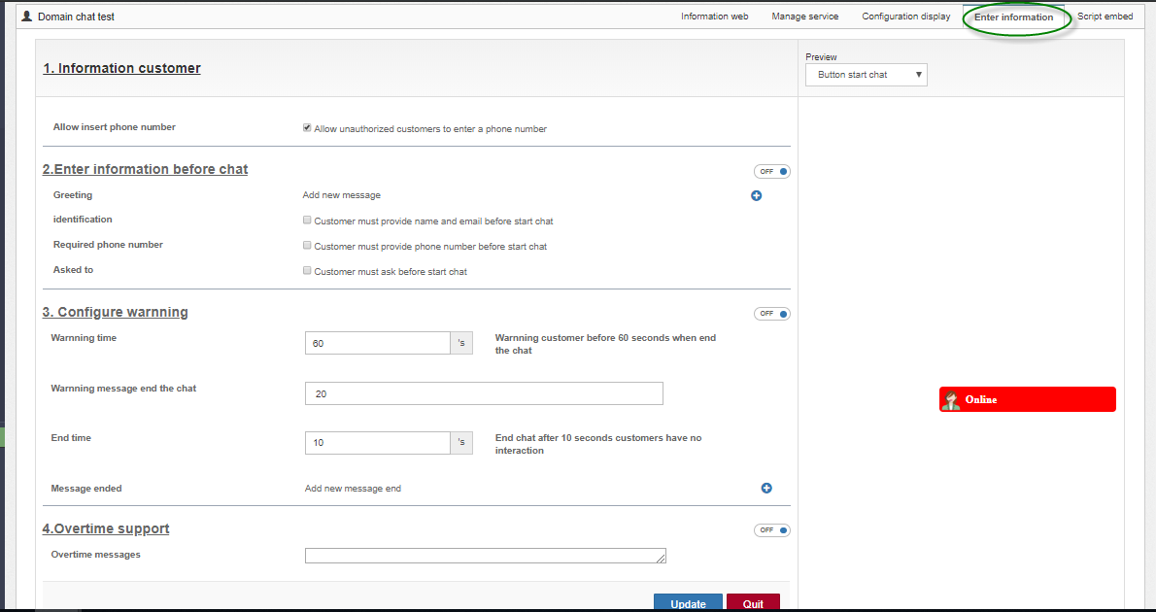

* Note: section “4. Overtime support has not applied yet.”

#### Tab Script embed

* Allow users to view domain scripts generated by the system itself. When deploying a web chat channel, it is necessary to embed this script on the web page to display the domain.

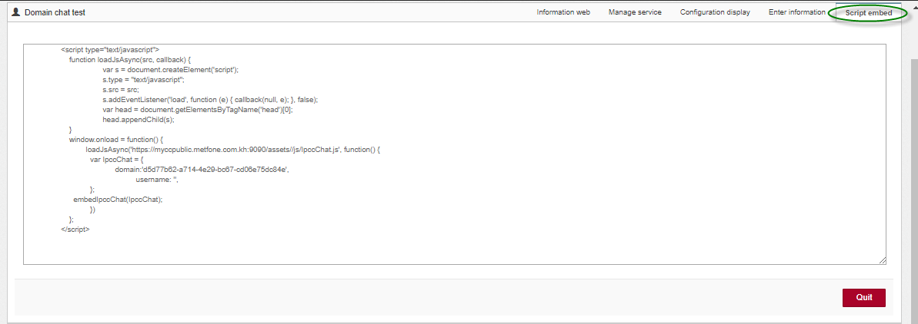

#### Delete Domain

* Step 1: on Domains setting, click icon “Delete at which domain you want to delete.

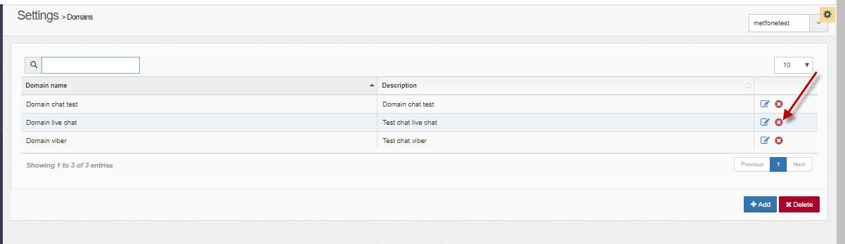

* It shows :

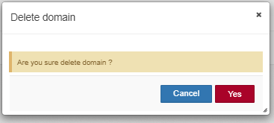

* Step 2: Click “Delete” button.

## Assign Agent to Queue Chat / Queue Ticket

* Description: The function allows users to assign agents to Queue Chat / Queue Ticket (Voice Queue uses other features).
* From menu, choose Settings/ Users -> click “Queue” tab:

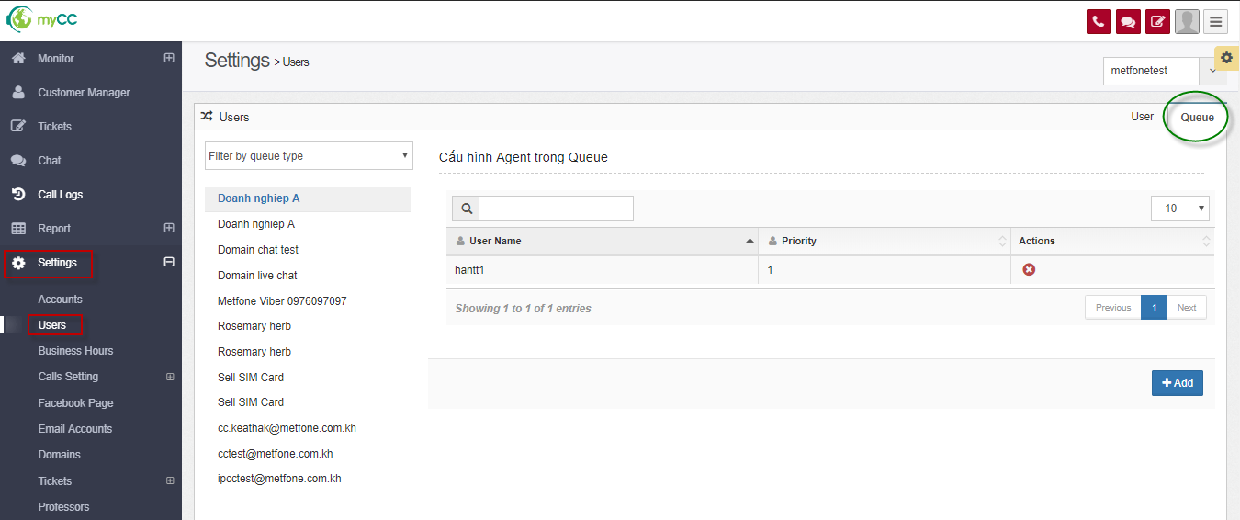

### Assign agents to Queue

* Step 1: On the "Queue" tab, click to select Queue you want to assign in the left menu -> The system displays the list of assigned agents in the corresponding Queue in the right pane
* Step 2: Click button **“Add”**

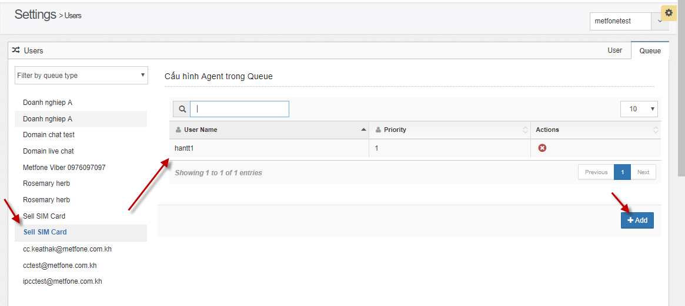

* It shows:

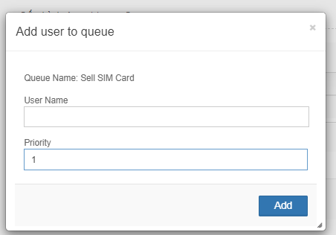

* Step 2: Input information:
  + User name:
    - Choose one or multi agents from list agents

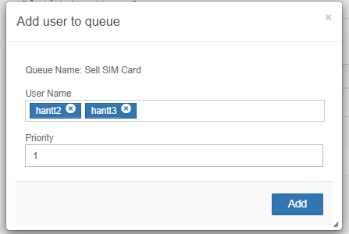

* + - Support relative search by agent when entering string into username box
    - Remove agent by choosing icon “x”
  + Priority: only enter numbers, which is the preferred value when assigned to the Queue Chat / Queue Ticket. The agent that is assigned to the Queue with the smaller the Priority value is prioritized first
* Step 3: Click **“Add**”

### Remove agents from Queue

* From list agents had assigned to queue, click icon “Delete” at which agent you want to remove.

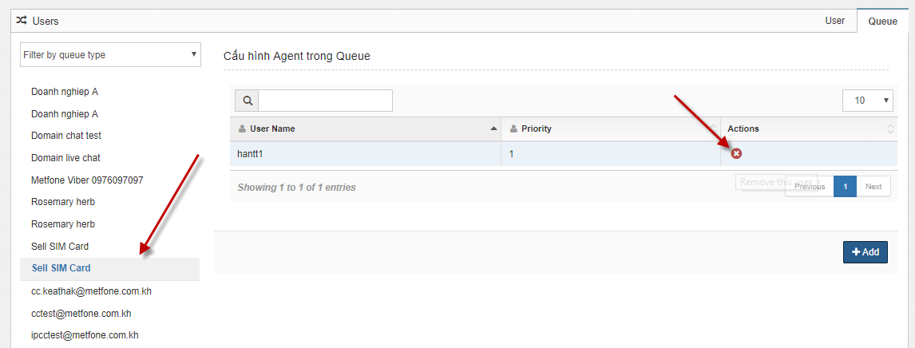

* It shows:

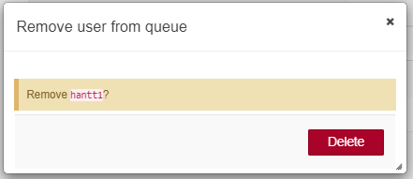

* Step 2: Click **“Delete”** button.

## Business Hours

### Working hours

* From menu: Choose : Settings/ Business Hours 🡪 Tab: Work Hours

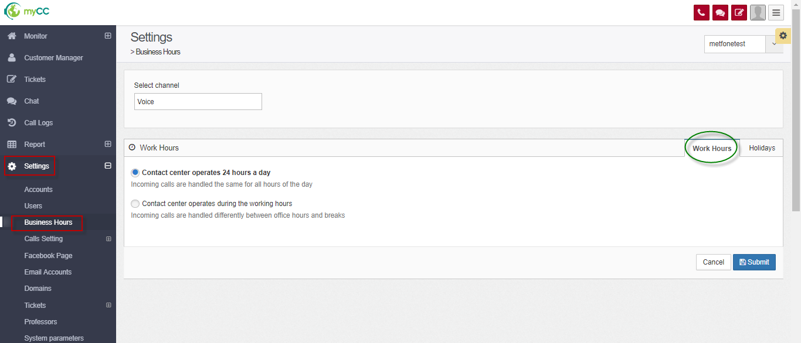

- Choose channel:

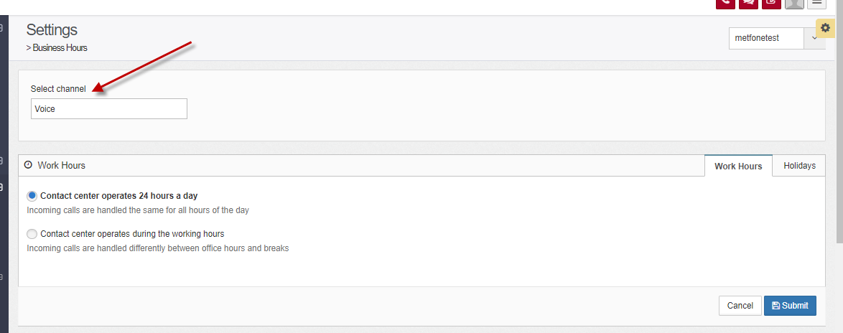

- Step 3: Choose working hours:

* 2 options:
  + **Contact center operates 24 hours a day**

**(**Incoming calls are handled the same for all hours of the day)

* + Contact center operates during the working hours

(Incoming calls are handled differently between office hours and breaks)

* If you choose: Contact center operates during the working hours, it shows:

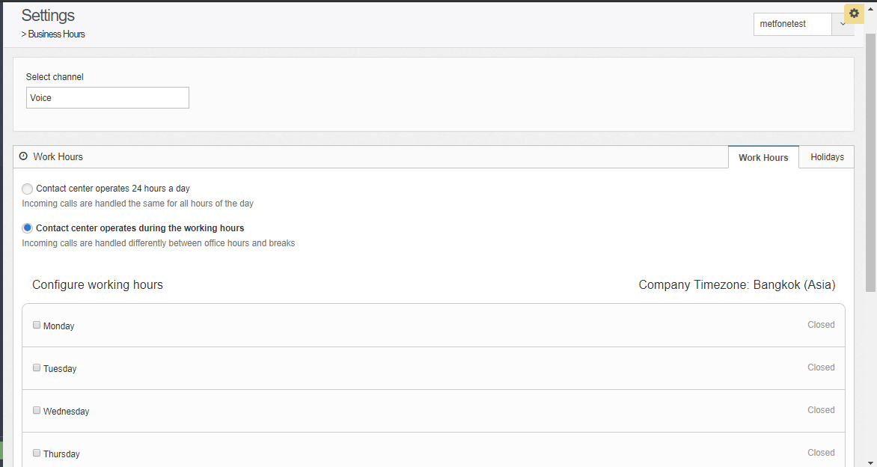

+ Click the checkbox to choose day of week and input time to work : from … to like: 08:00 🡪 17:30

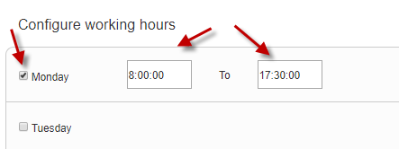

+ Click the checkbox and input time break for agents have lunch:

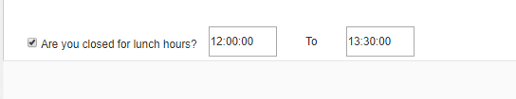

Noted:

* If the user enters alphabetic characters, special characters -> the system will automatically convert the value back to 00:00:00
* In case the user enters the wrong time format: divided into cases:
* Enter the time as an integer,> = 0, in the format hh: mm: ss but not in the correct format 24h -> the system converts the time to the nearest format to the nearest data entered.

example: If you enter: 40:50:00 🡪 it will be converted to: 23:50:00

If you enter 12:70:00 🡪 it will be converted to: 12:59:00

If you enter: 12:30:80 🡪 it will be converted to 12:30:59

* If you enter data as a decimal number, the system converts the time to the nearest format to the closest data entered (remove the dot)

example: 1.2.3.4.5.6 -> converted: 12:34:56

* If the user enters a negative number, the system automatically converts the time to the nearest format to the nearest data (remove the minus sign)

example: -1-2-3-4-5-6 -> converted: 12:34:56

* Step 4: Click “Submit” button.

Some notifications of the system:

* Case 1: If you don't select anything during the week, the system notifies: "There must be at least one working day." Therefore users are required to choose at least 1 day of the week.
* Case 2: After selecting any date, if the start time is left blank -> -> the system notifies: : ‘Selected date’: invalid worktime 🡪 need to enter the start time.
* Case 3: After selecting any date, if the end time is left blank -> -> the system notifies: : ‘Selected date’: invalid worktime🡪 need to enter the end time.
* Case 4: After selecting any date, if the start time is equal to the end time -> the system notifies: : ‘Selected date’: invalid worktime 🡪 need to enter a start time smaller than the end time.
* Case 5: After selecting any date, if the start time is greater than the end time -> the system notifies: : ‘Selected date’: invalid worktime🡪 need to enter a start time smaller than the end time.
* Case 6: After selecting: "Do you close the lunch hour?" : if you enter an invalid start time and end time -> notification system: invalid lunch time 🡪 need to enter a start time smaller than the end time
* Case 7: If you enter valid time for selected date 🡪 it shows : Update successfully!
* Case 8. Click “Cancel” button to cancel off configuration.

### Holidays

- Step 1: From menu, choose: Settings/ Business hours 🡪 choose tab: Holidays:

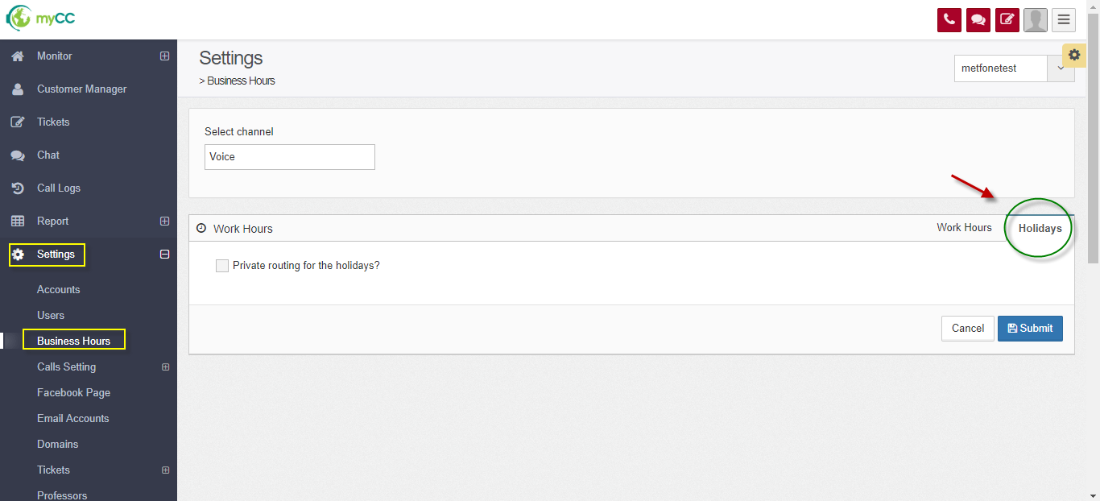

- Step 2: Choose channel (do not apply to Voice channel)

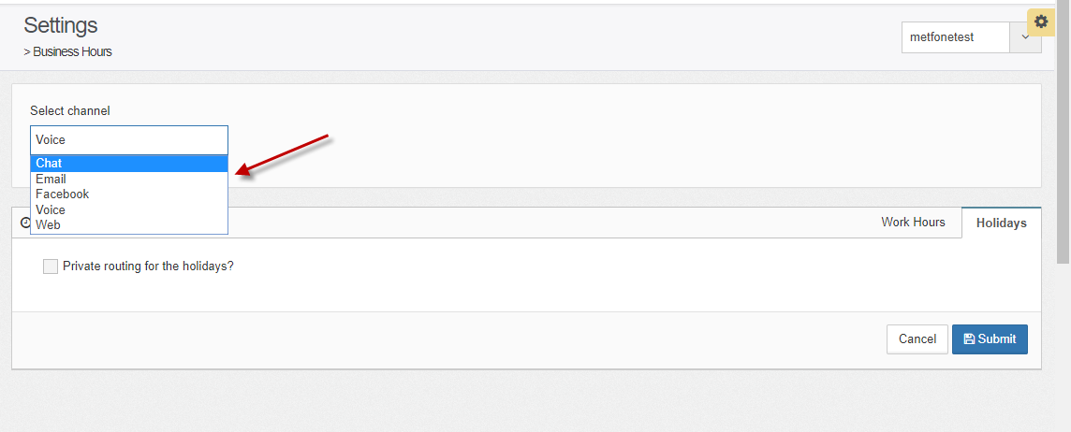

Click the checkbox “Private routing for the holidays?” (optinonal)

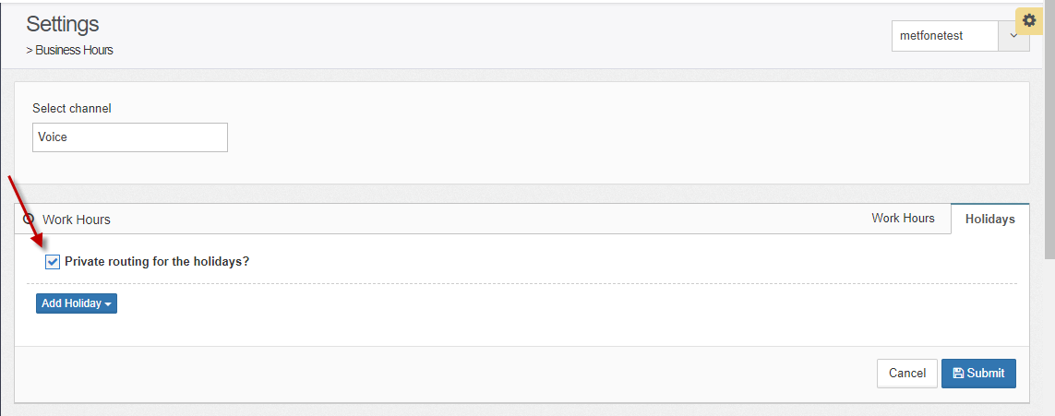

Click “Add holiday” button: choose Add Day or Add Period:

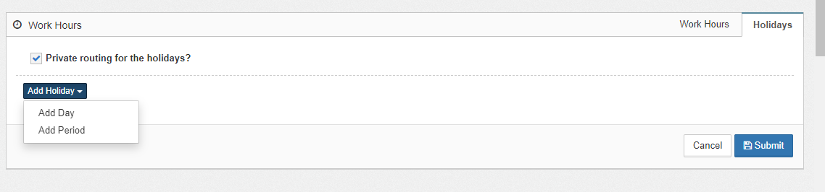

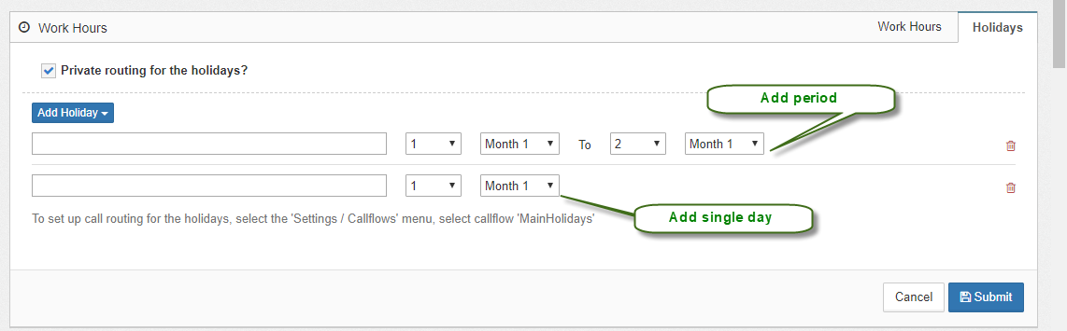

Enter information:

+ Name of day off

+ Choose date, month, year

Click “Submit” button.

Noted: The system will display error messages in case the user entered the wrong or missing information:

* Holiday name can not empty
* Invalid holiday period

Click icon  to delete holiday.

## Manage Facebook page

From menu: Choose Settings 🡪 Facebook page:

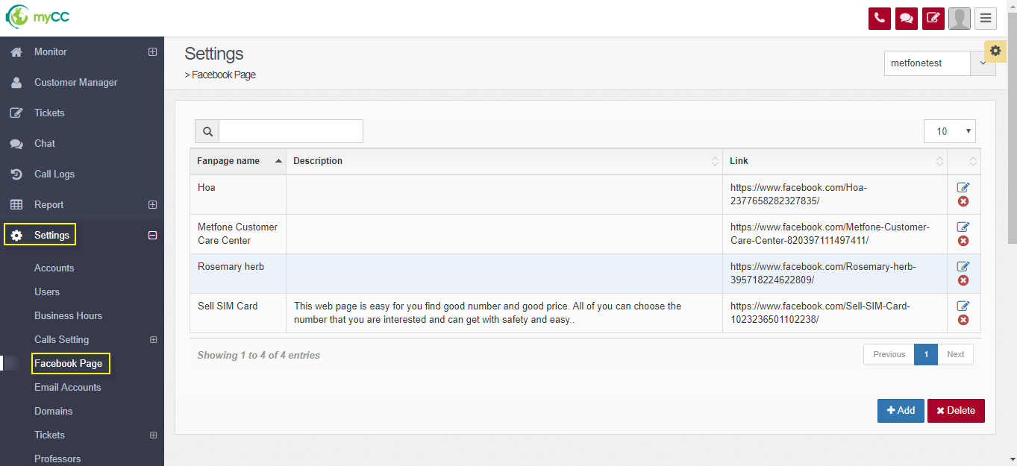

Click “Add” button:

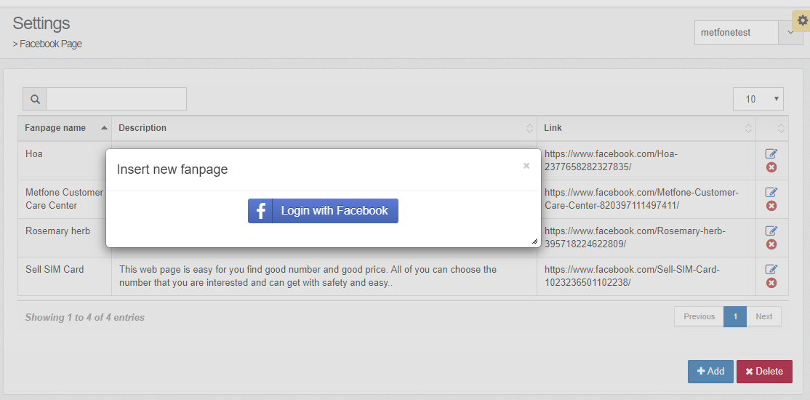

Click “Login with Facebook” 🡪 it shows:

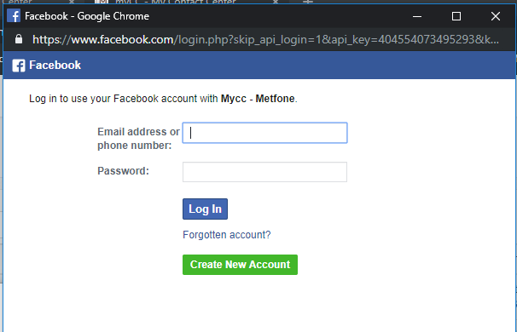

Enter information (with administration account) then click Login:

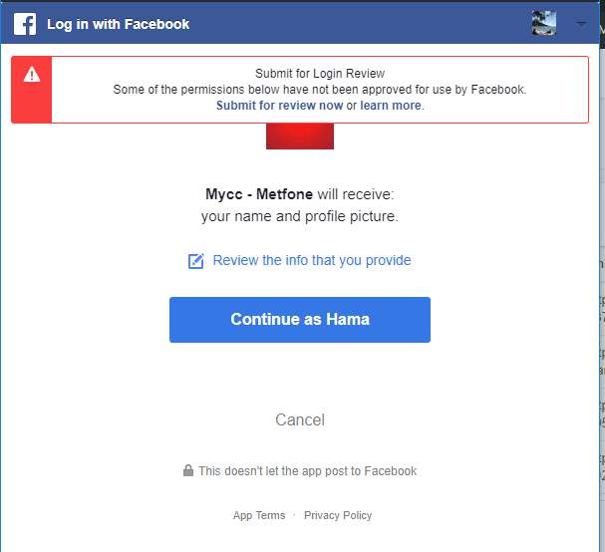

Click “Continue as ..”

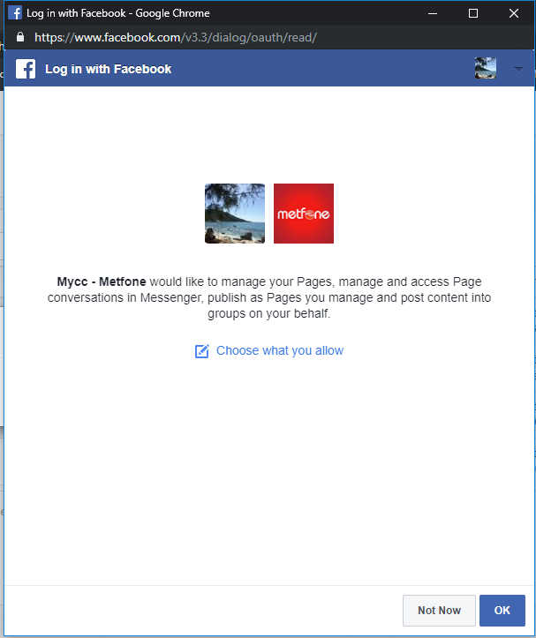

If you click “Choose what you allow” it shows:

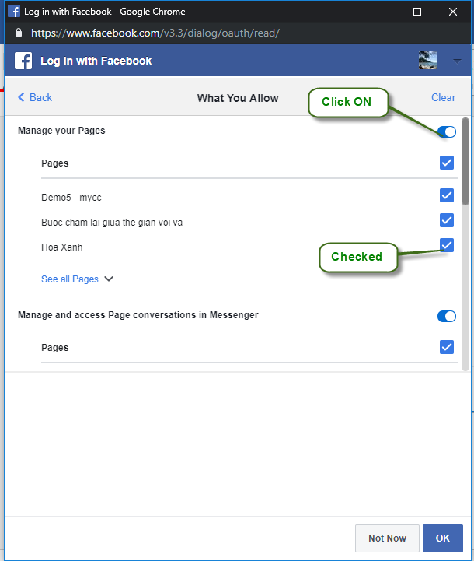

You need to allow to all powers: (Choose ON with powers and click checked at pages)

* Manage your pages
* Manage and access Page conversations in Messenger
* Publish as Pages you manage.

Then, click “OK” button 🡪 it shows all your page on screen:

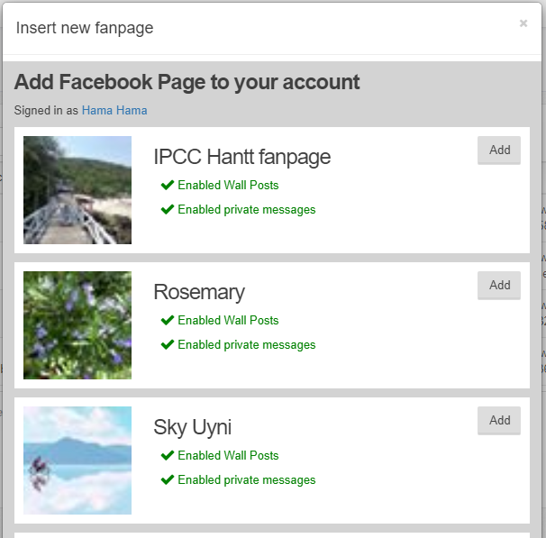

Click “Add” with page you want to add to myCC.

Notes: choose all options:

* Enable Wall posts : means: allow myCC to get the posts/comments on the page -> create the tickets and assign agents to process.
* Enable private messenger: means: allow myCC to receive customer messenger conversations to your page 🡪 create new chat and allocate to agents to chat with customers.

Add page successfully, the system shows a notification:

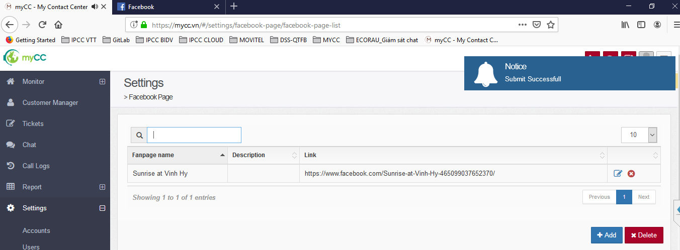

** For administrator:

When adding new pages successfully with the above two options, auto-queuing system 2 queues (Queue chat facebook: allocate chat conversations for agents and Queue ticket Facebook: get comments / posts on the page, create a ticket and allocate to the agent for processing).

The administrator of the enterprise that needs to assign agents to these 2 queues so that the agent can receive chat allocation or ticket allocation with the source of the facebook page.

** Guide to assign agents to Facebook ticket queue and Chat facebook queue:

From the menu, choose: Settings/ Users -> click Queue tab:

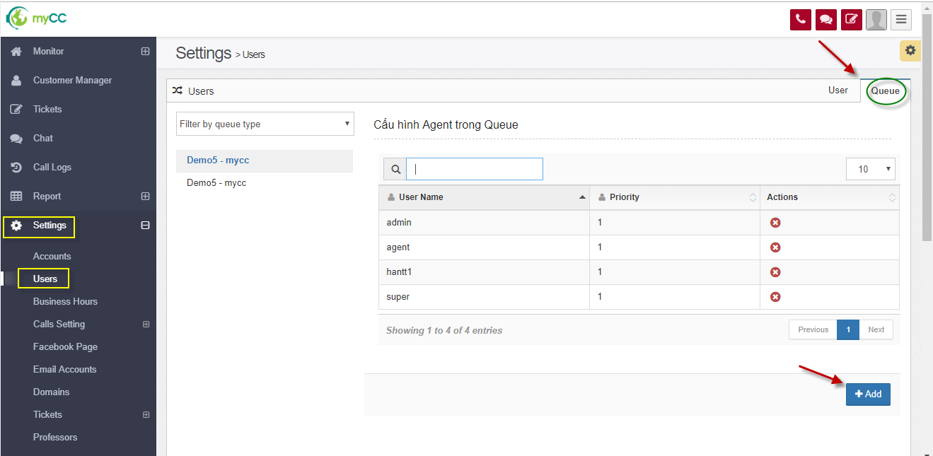

Click “Add” to assign agent to queue.

Noted :

* Assign agent to the corresponding queue is the Queue chat or Queue ticket. Click search to select the corresponding queue:

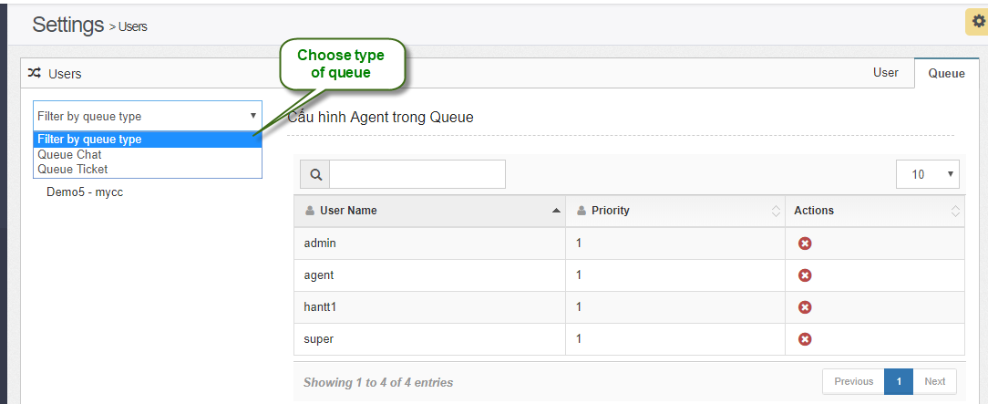

* At one point, an agent can receive multiple chats, process multiple tickets. When configuring the user, admin can change configuration parameters: max chat transactions, max ticket transactions of each agent in the section: Settings / Users:

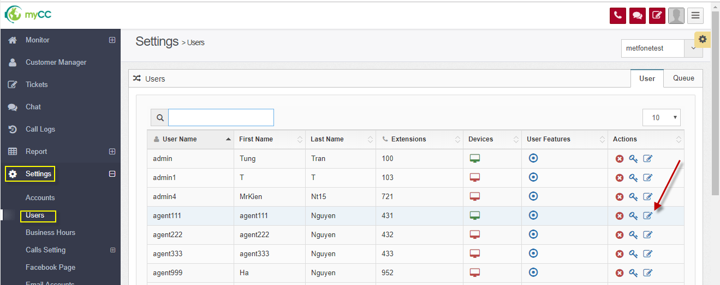

Choose update one agent:

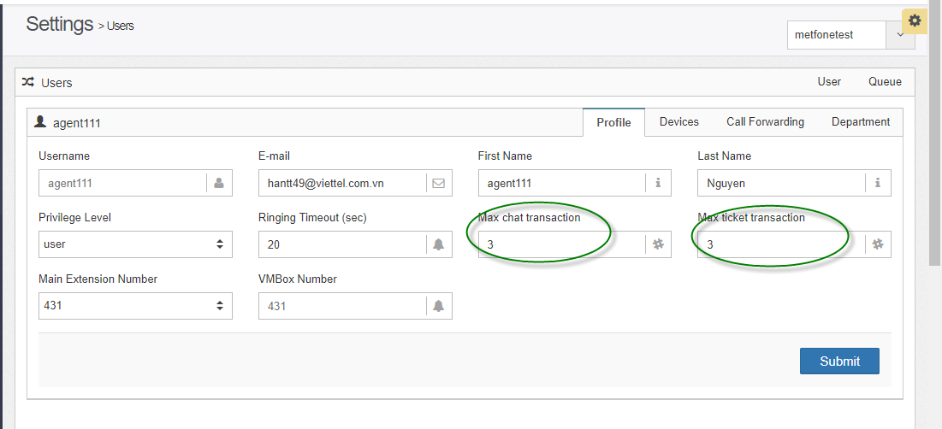

Change information and click “Submit” to save.

** Instructions for users to receive customer chat from the facebook page integrated into myCC system.

Agents login the system. From the menu, choose: Chat :

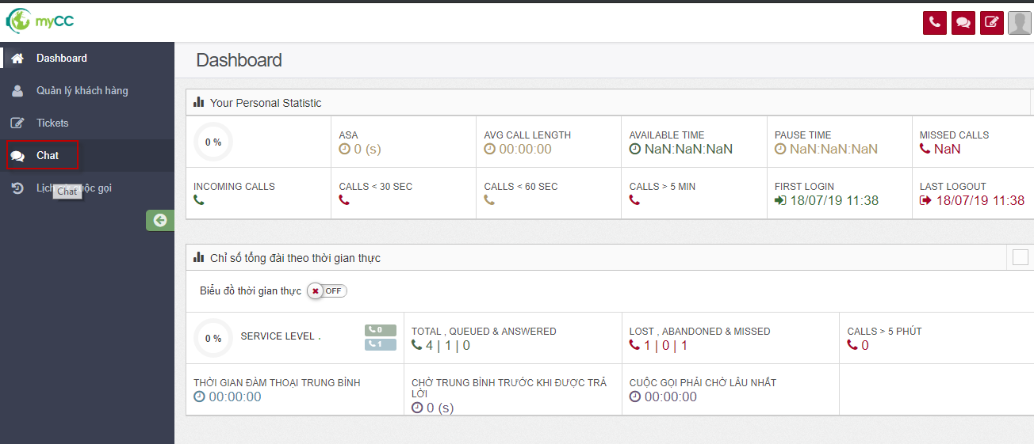

It shows:

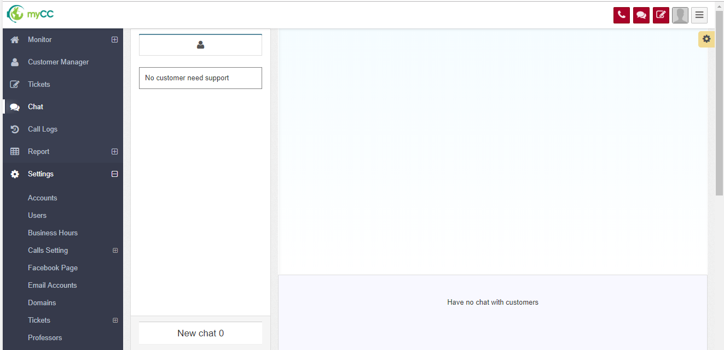

After the admin assigned to queue chat, the agent needs to change the chat channel status to AVAILABLE in order to receive chat allocation: 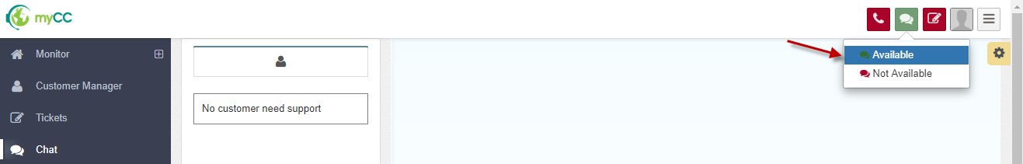

When a customer performs chat inbox to the page, the auto-get system chat about and distributes to agents assigned to the Chat queue.

The agent receives a new chat distribution, on the agent screen displayed as follows: 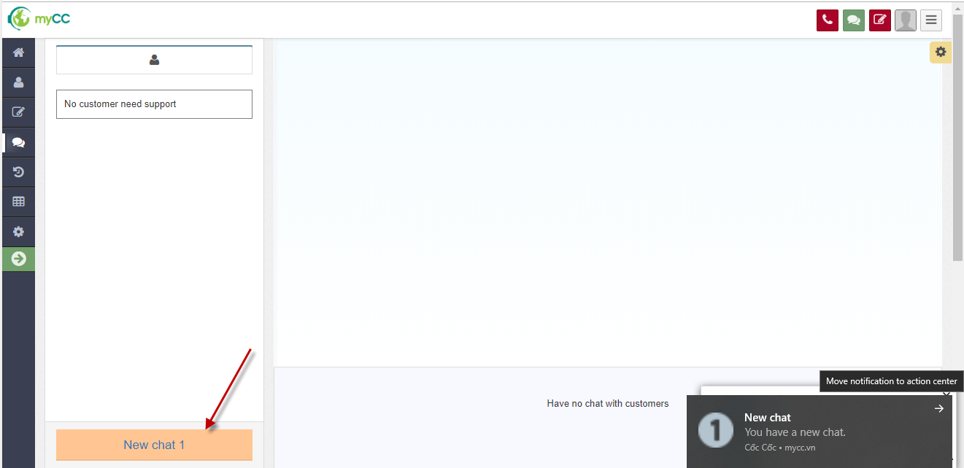

The agent clicks to “New chat 1” button to receive chat:

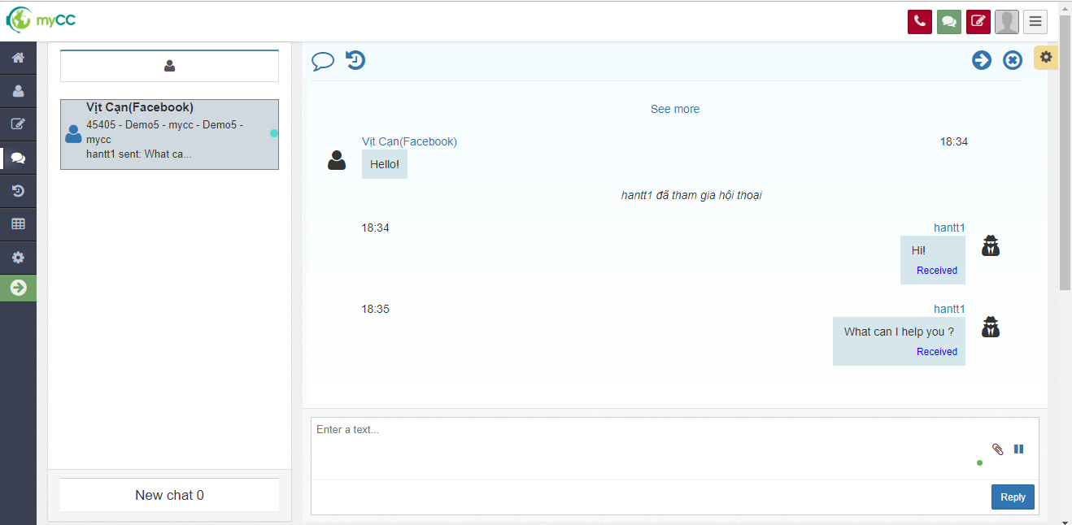

The agent enters information to chat with the customer.

The agent click icon  to actively end chat.

The system will automatically send a message to the customer.